Copilot Assistant Management Tool

JUan Salvador Huertas Romero

2025

Contents

Power APP Interface 3

Create order Table 3

Enable record creation through a form interface 5

Implement navigation within the app 5

Implement navigation within the app 2 6

Demonstrate the ability to create a personalized app interface 6

User Name 7

Navigate 7

ChatBot Screen 8

Copilot Agent 9

Overview 9

Knowledge 10

Tools 10

Topics 11

Detail 11

Output 13

Create New Topic 13

Configure topic triggers for the Copilot Agent 14

Design message responses for Copilot Agents 14

Testing agent Topic 15

Demonstrate user interaction with the Copilot Agent 15

Another Test 16

Copilot / Power Flows 17

Overview 17

Design 17

PowerApps 19

Same but view Details from Power App Flows 19

Create a record in Dataverse using Power Automate 20

Verify Creation In Table 22

Integrate Copilot functionality into the app 23

APP Demo 24

Welcome Screen 24

Demonstrate navigation logic using Power FX (Click in Check In) 24

Search Order 25

Create New Order in Application 25

Demonstrate user interaction with the Copilot Agent 27

Open Creation New Agent Button 28

Publishing Agent to Copilot and Teams Channel 31

Teams Agent (Demonstrate user interaction with the Copilot Agent) 32

Teams Copilot (Demonstrate user interaction with the Copilot Agent) 33

Solution Copilot Assisted Management Tool 35

Validate the structure of the Power Platform solution 35

Azure DevOps 36

VsCode 36

# Power APP Interface

## Create order Table

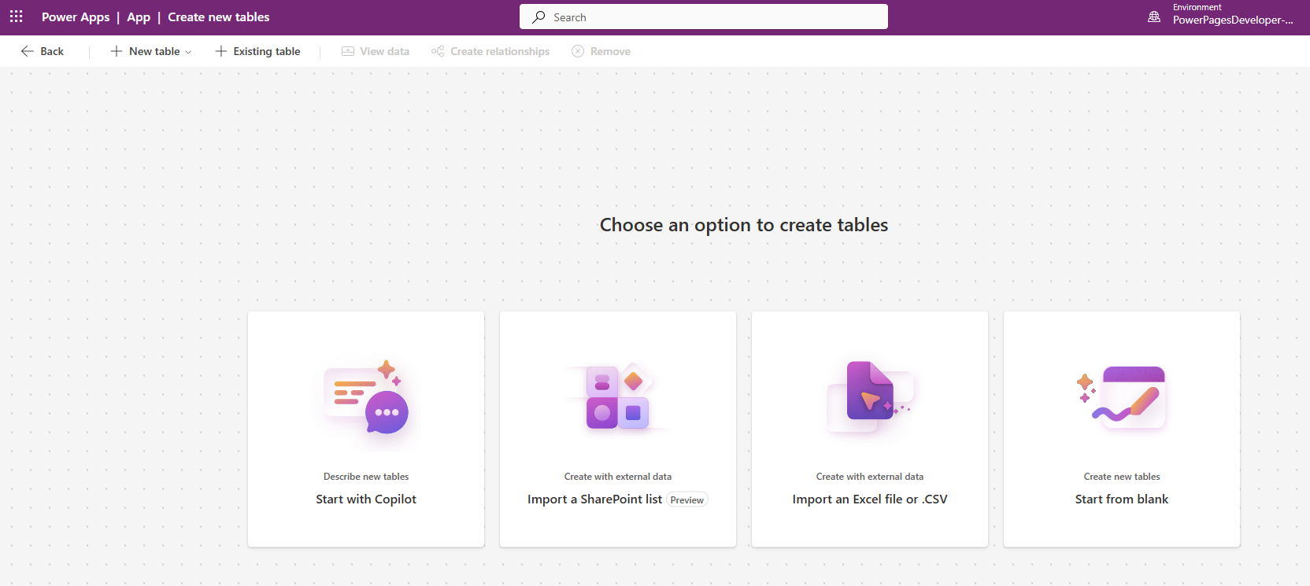

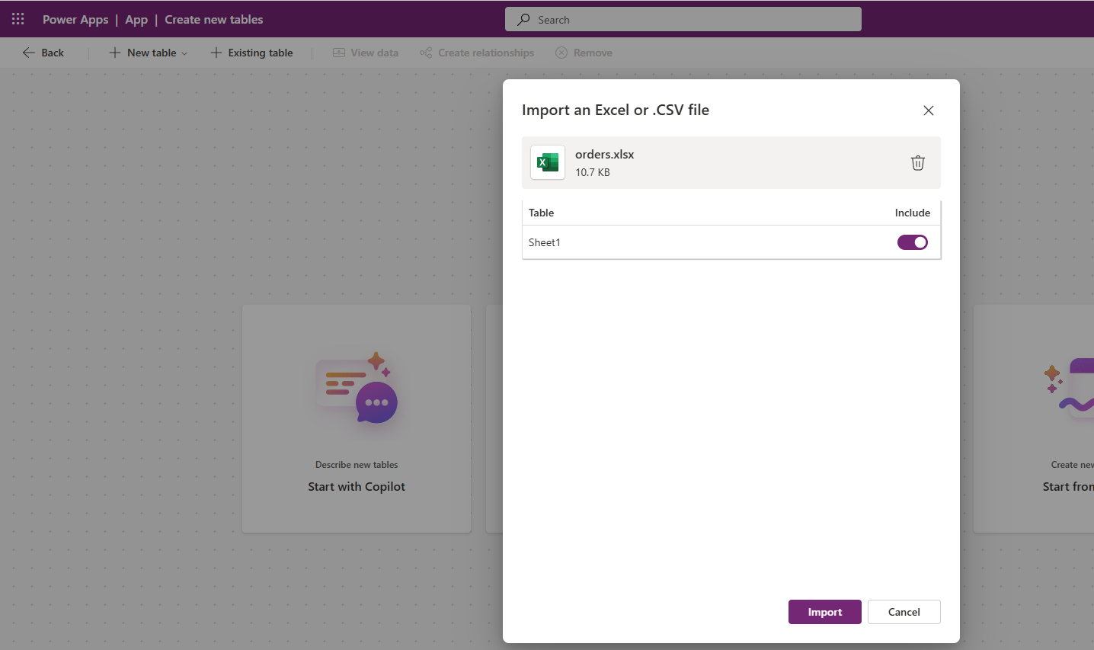

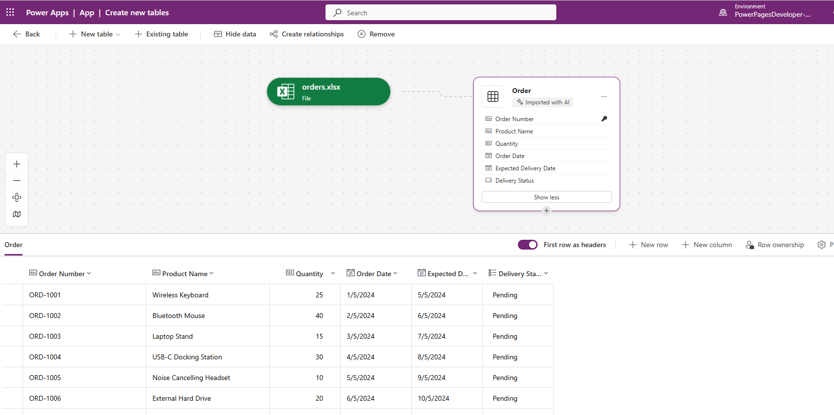

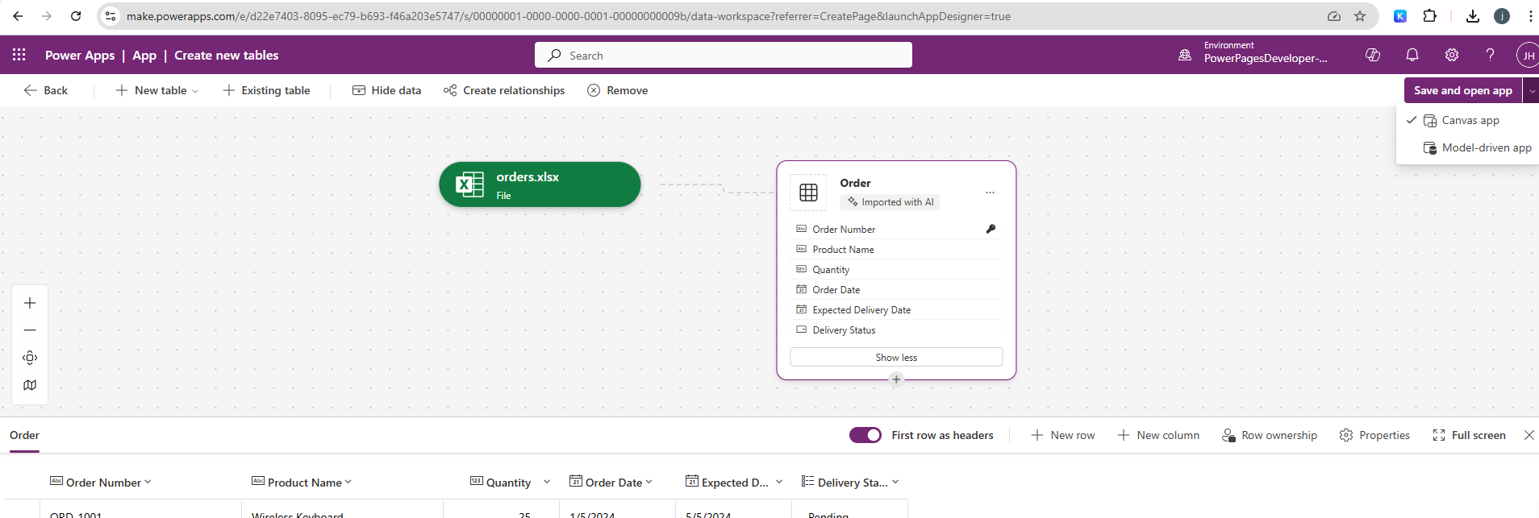

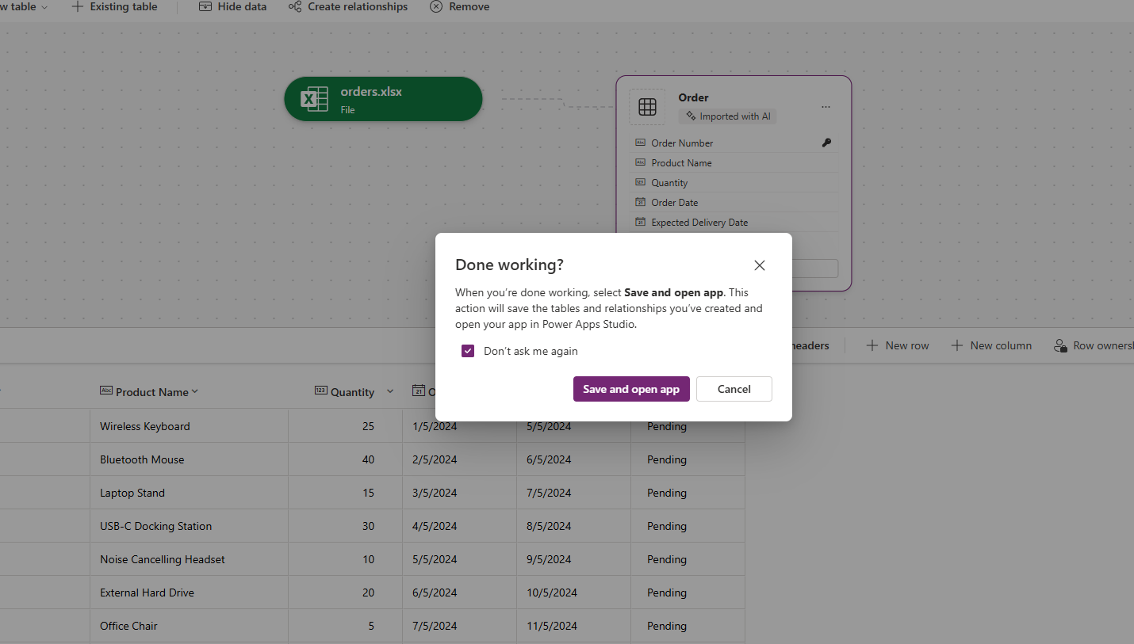

## Enable record creation through a form interface

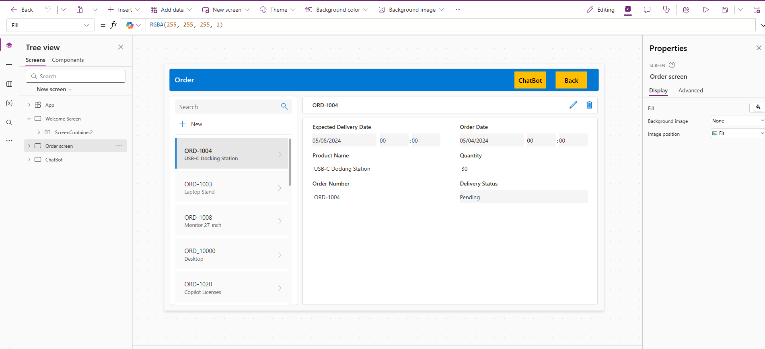

## Implement navigation within the app

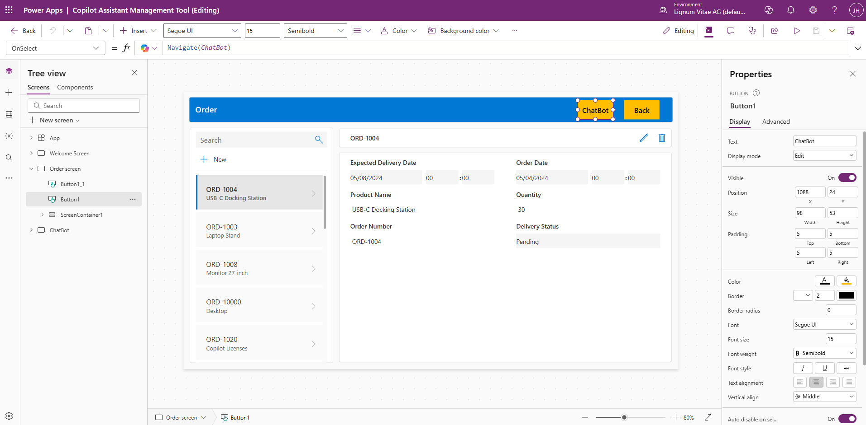

## Implement navigation within the app 2

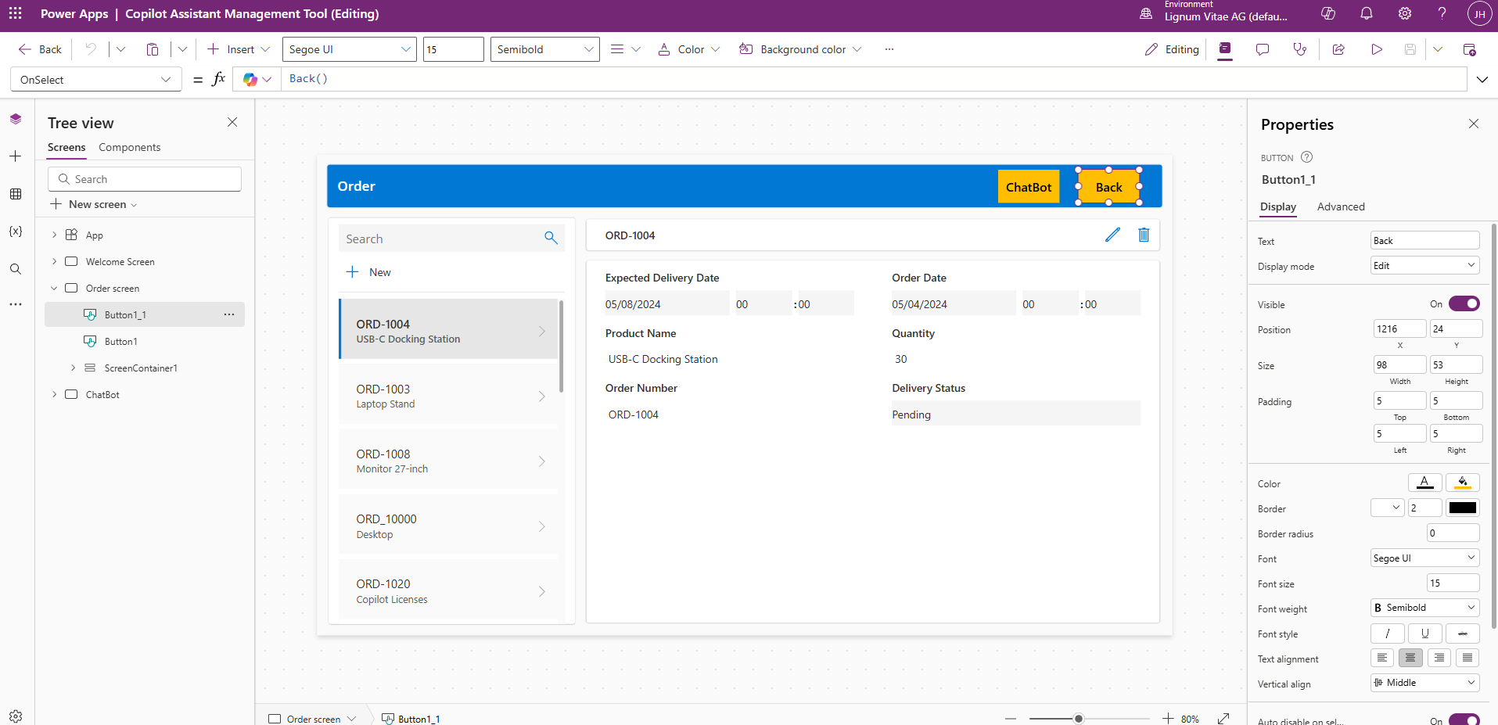

Demonstrate the ability to create a personalized app interface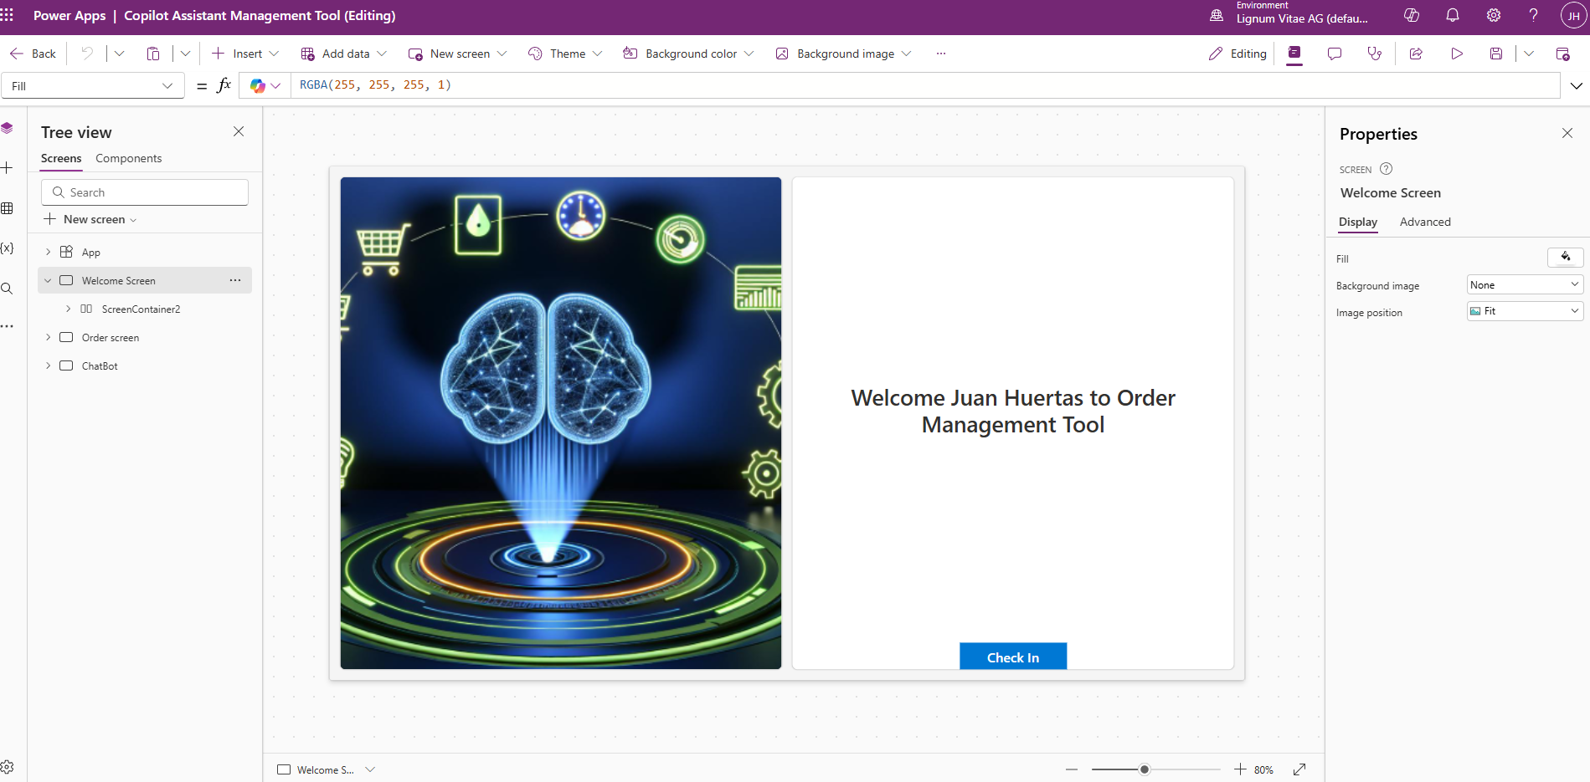

### User Name

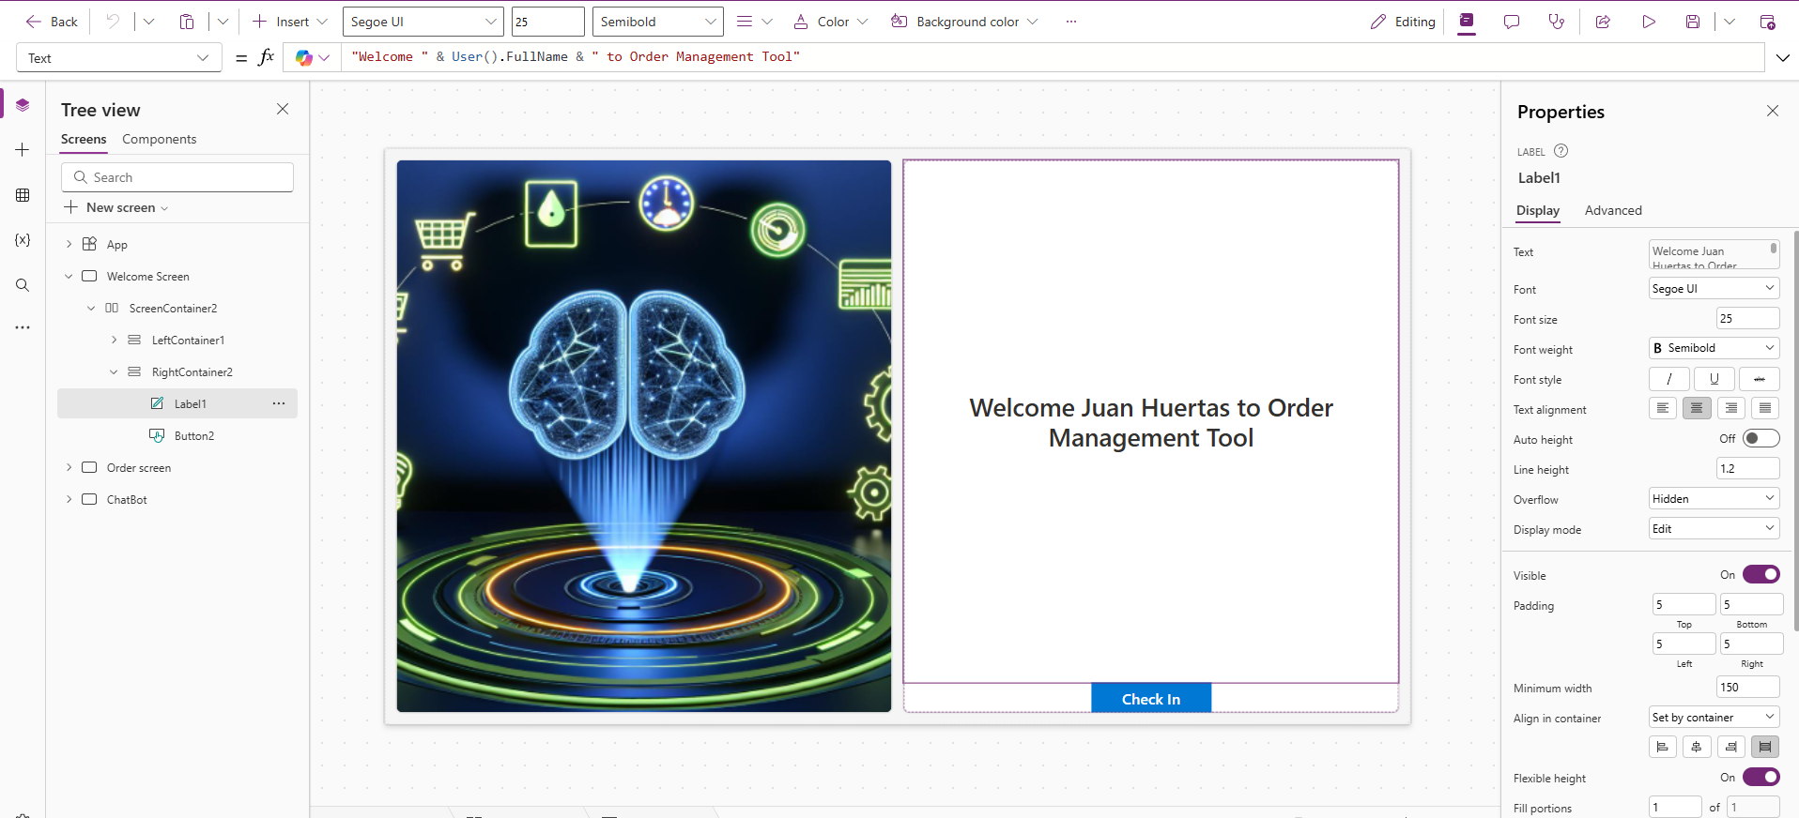

### Navigate

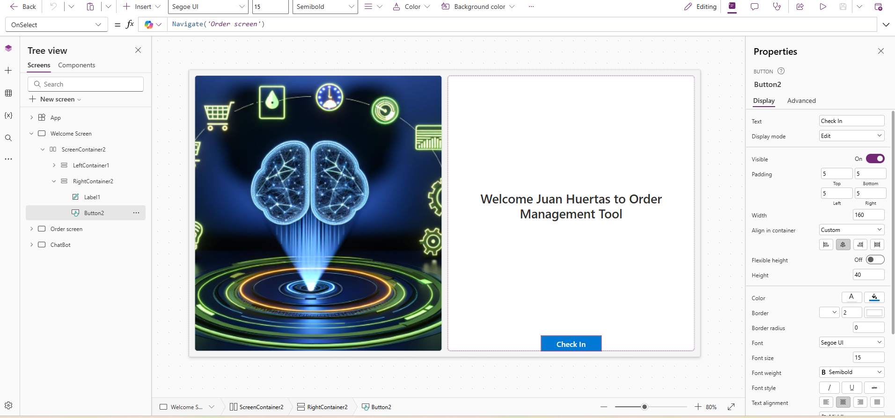

## ChatBot Screen

This contains a Copilot Component , Navigation to the different Screens.

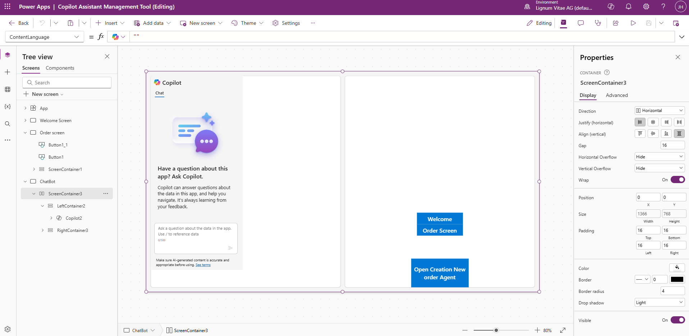

# Copilot Agent

## Overview

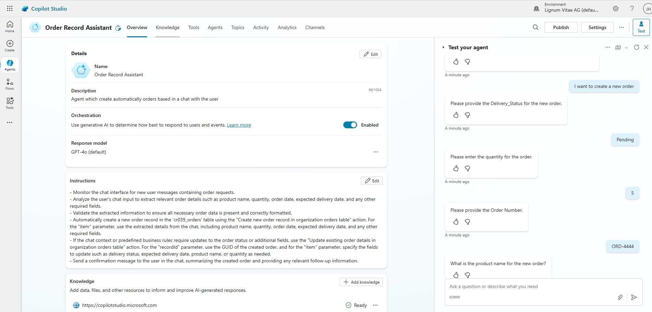

## Knowledge

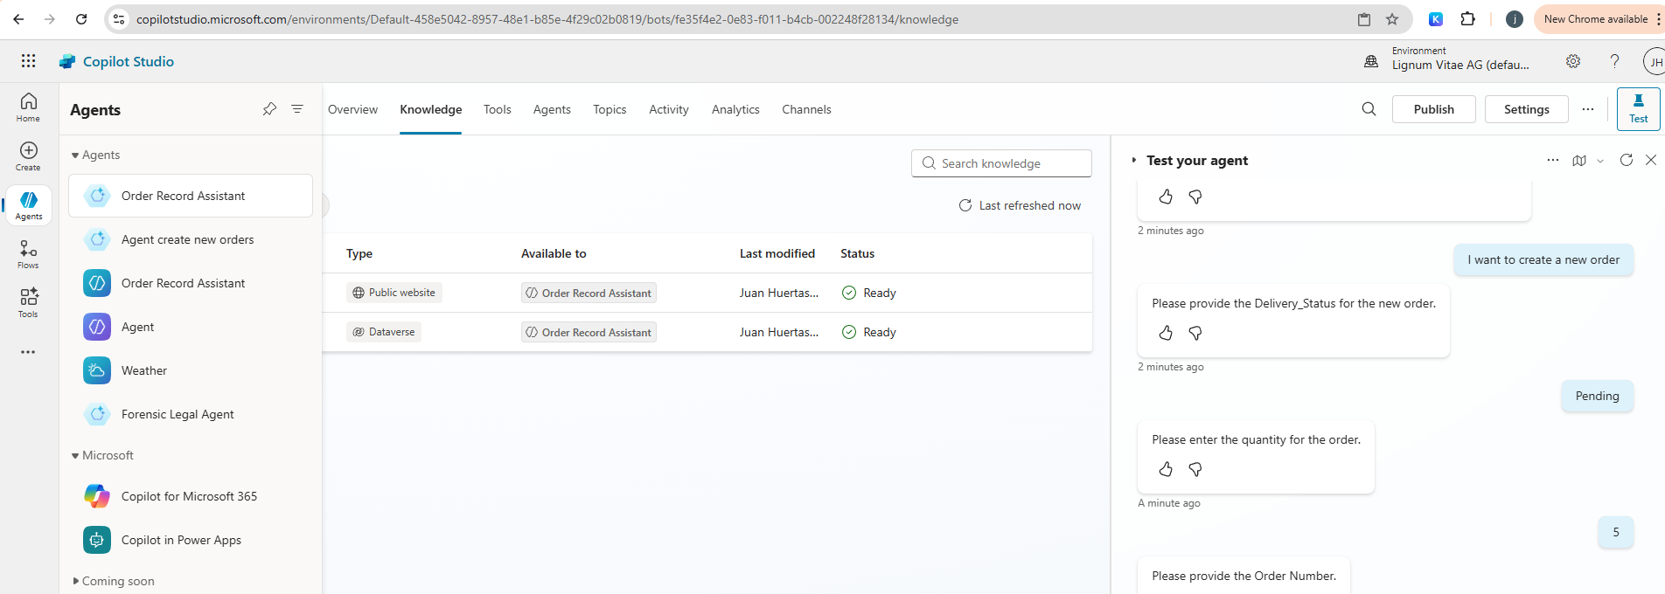

## Tools

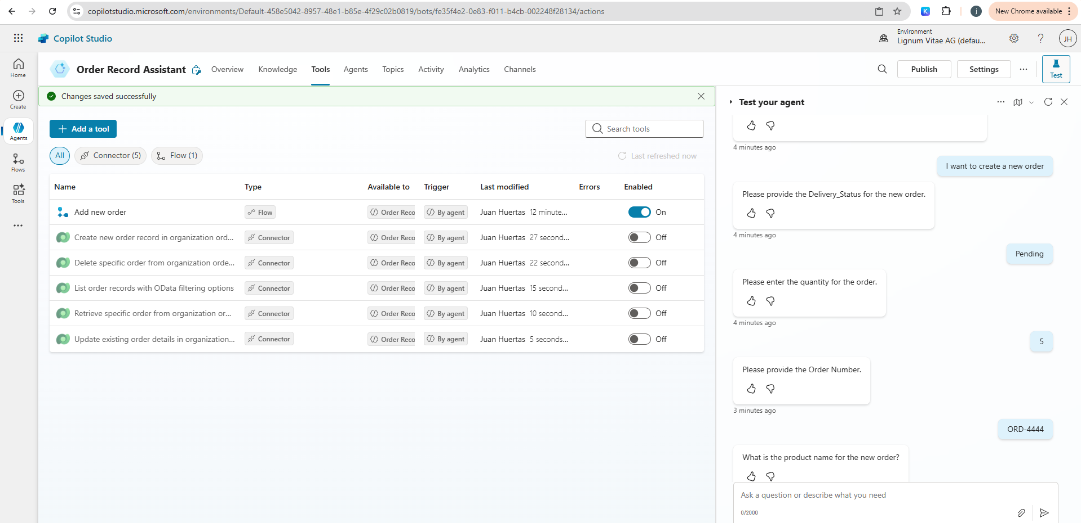

## Topics

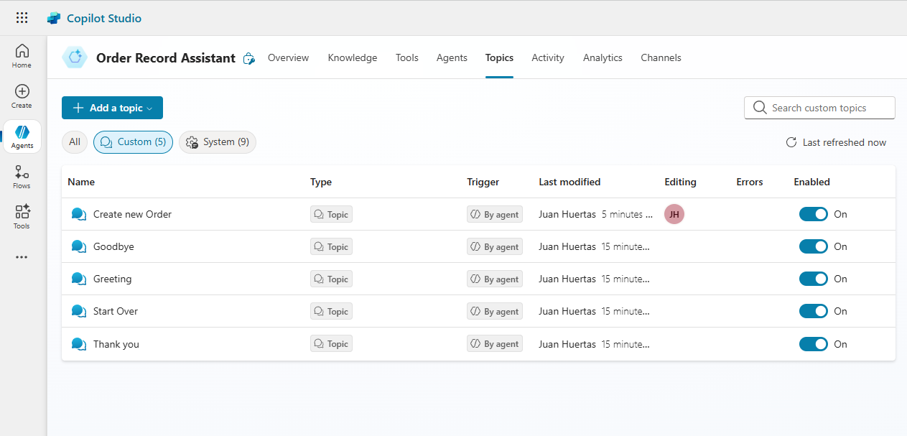

### Detail

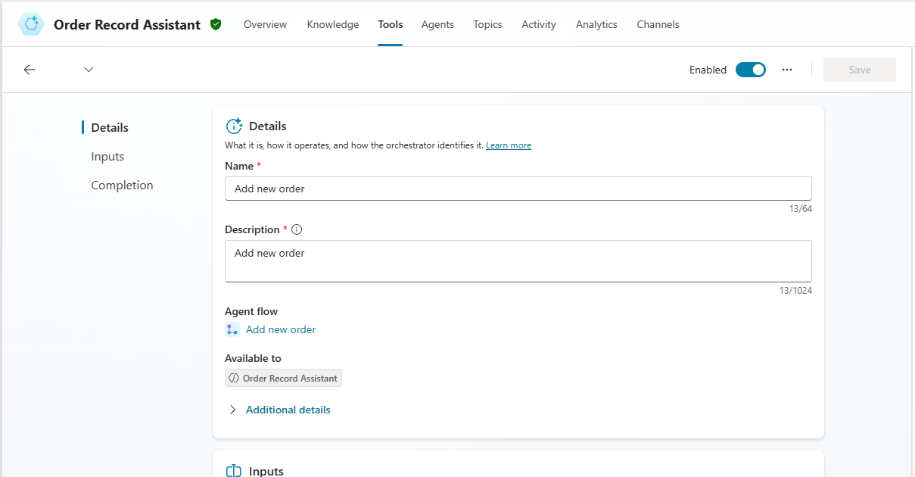

#### Inputs (Pass parameters to an automation in Power Automate)

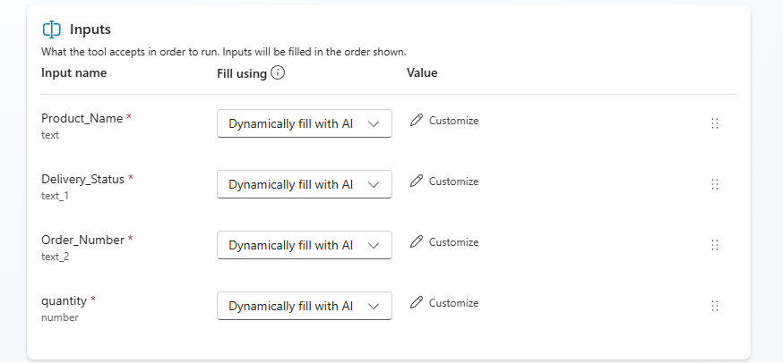

### Output

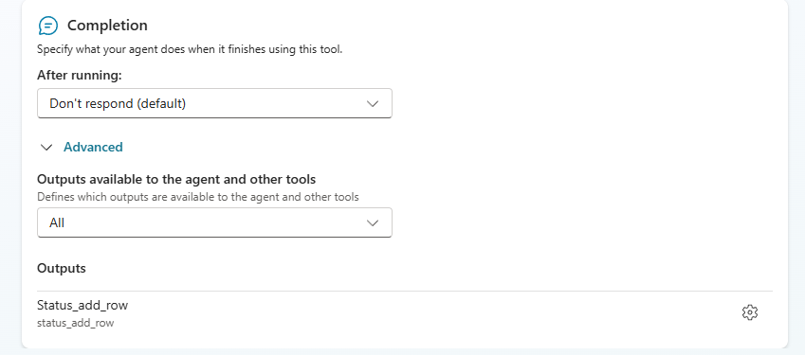

## Create New Topic

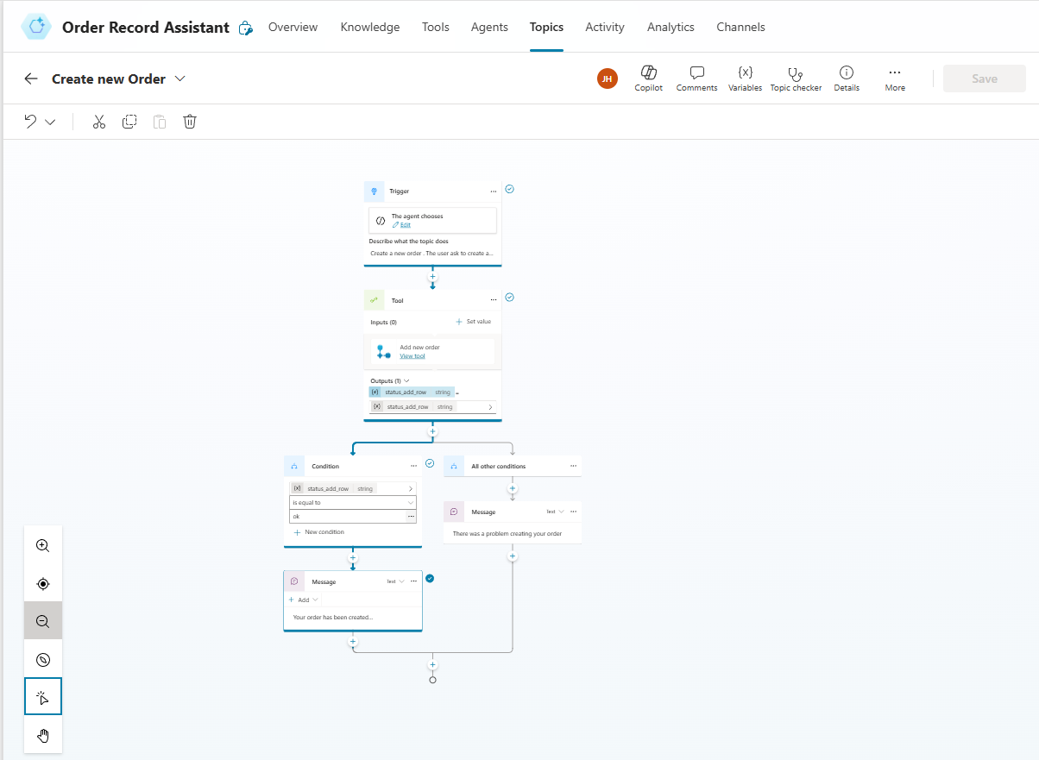

## A screenshot of a computer AI-generated content may be incorrect.Configure topic triggers for the Copilot Agent

## Design message responses for Copilot Agents

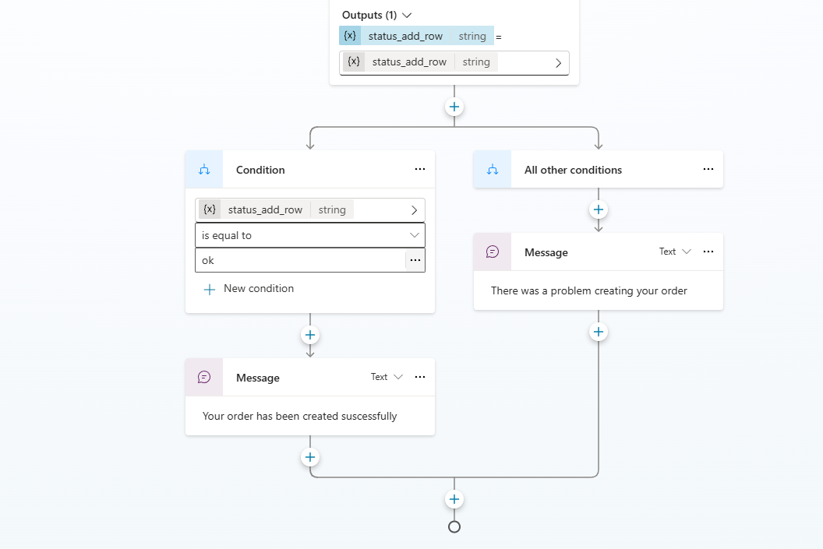

## Testing agent Topic

### Demonstrate user interaction with the Copilot Agent

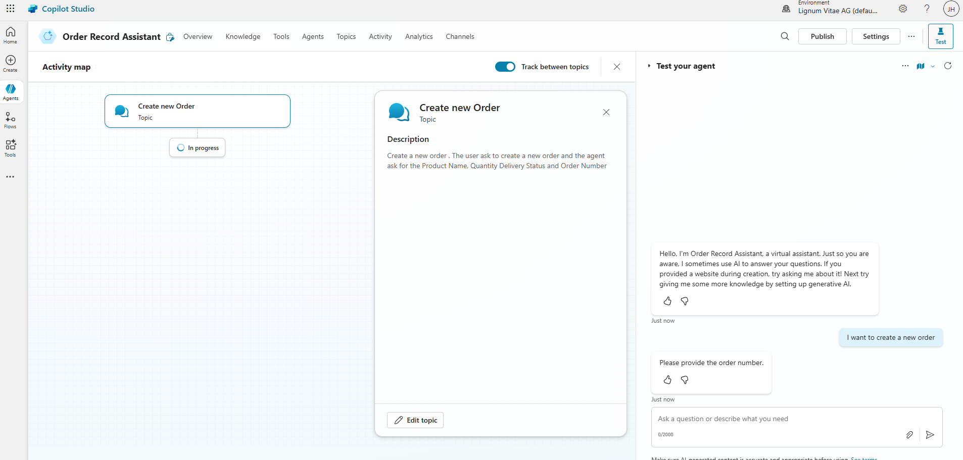

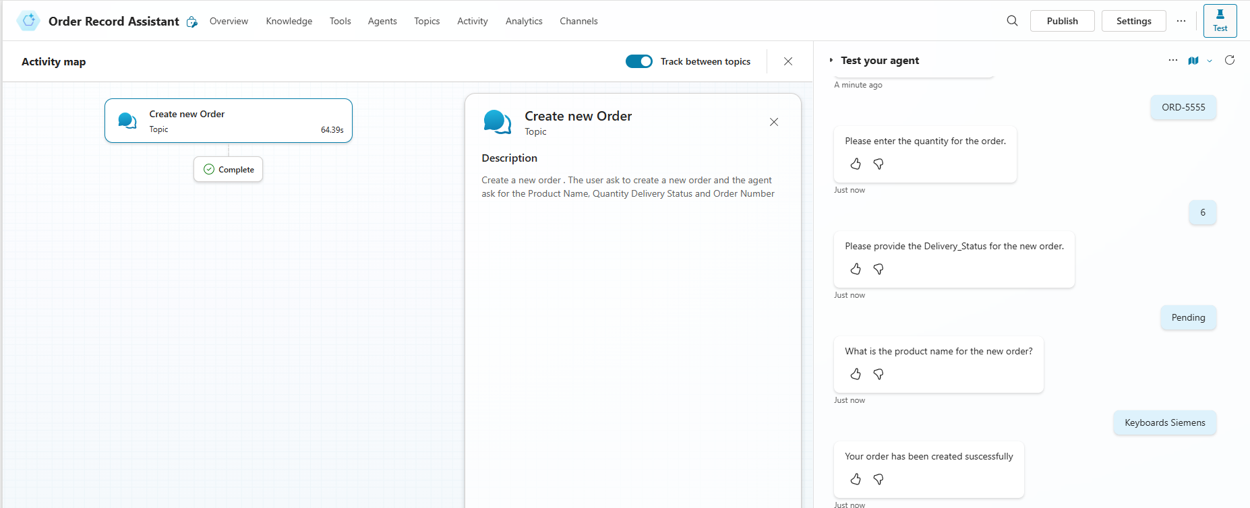

### Another Test

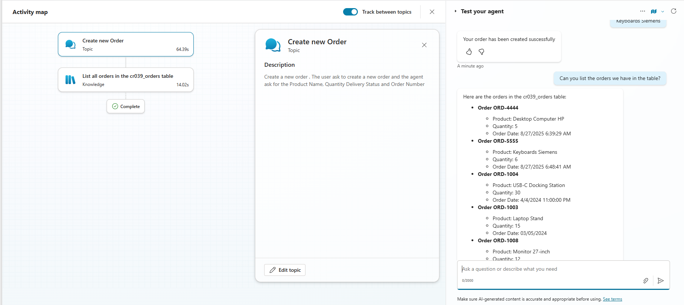

## Copilot / Power Flows

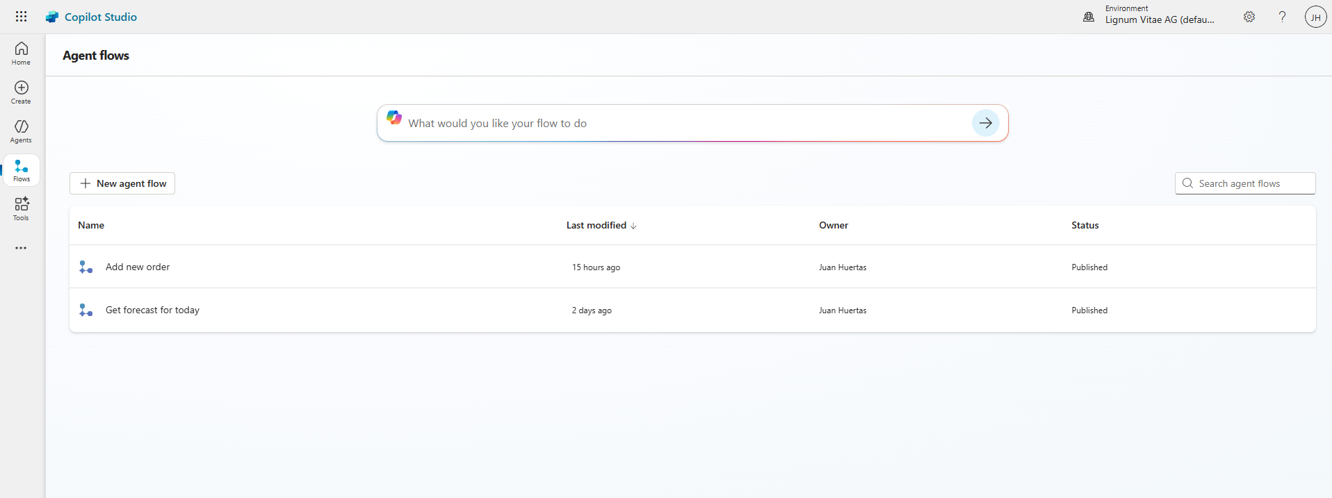

### Overview

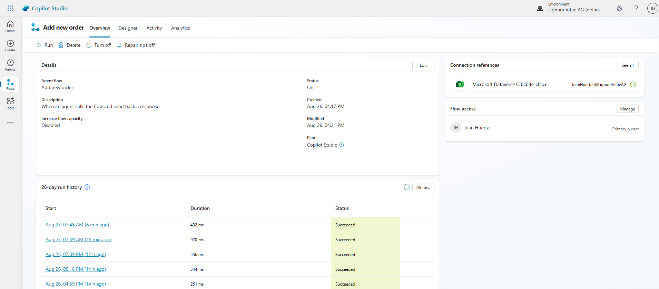

### Design

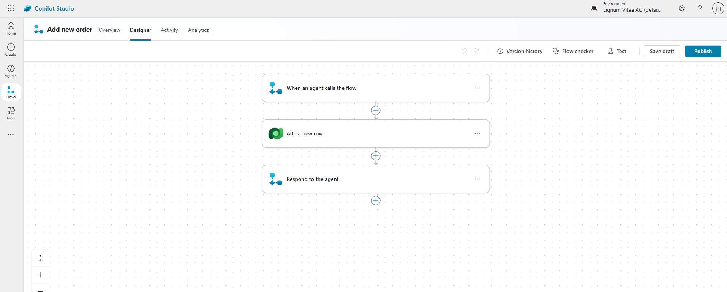

#### Inputs

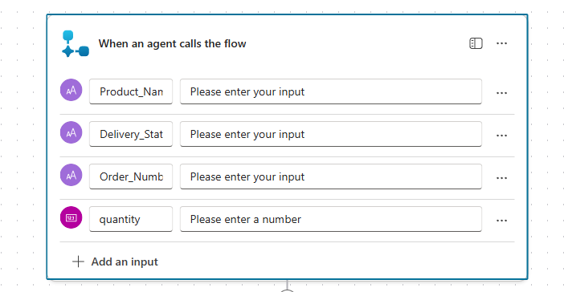

#### Add New Row to Dataverse Table

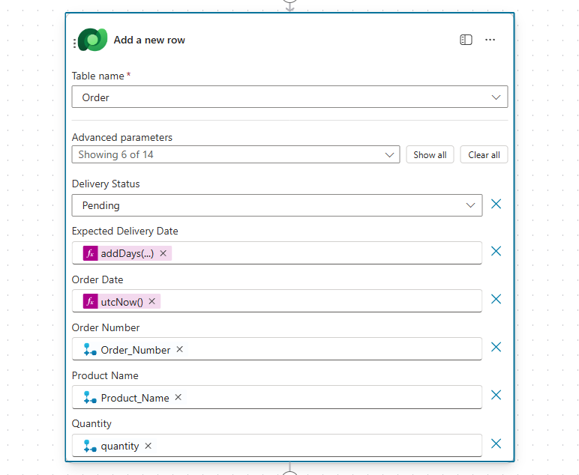

#### Outputs

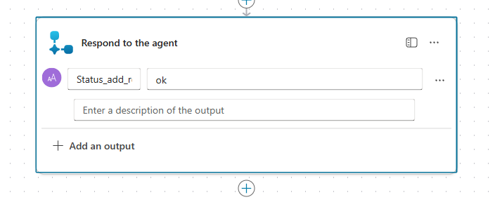

## PowerApps

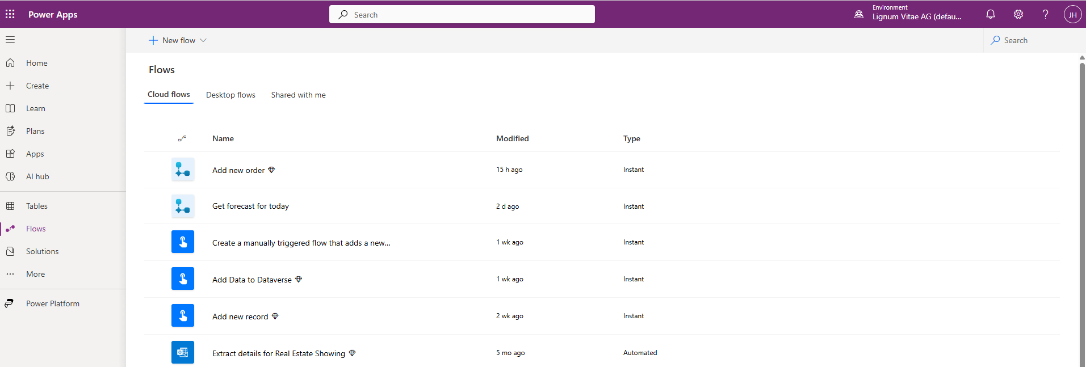

### Same but view Details from Power App Flows

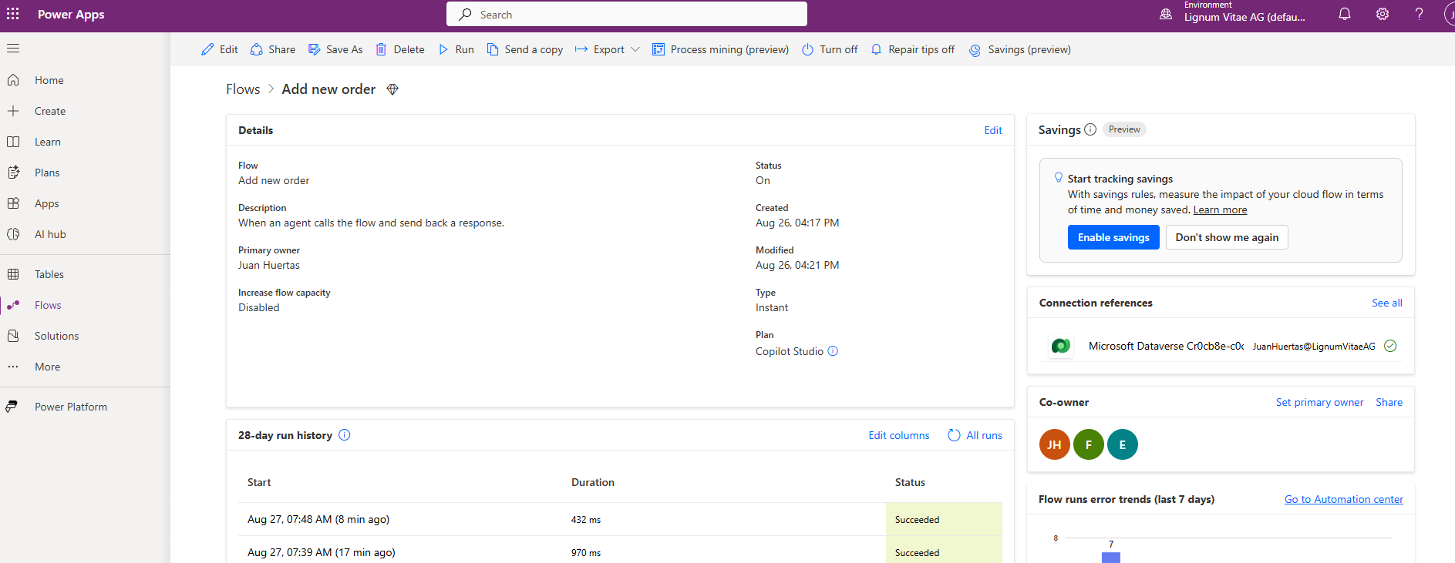

### Create a record in Dataverse using Power Automate

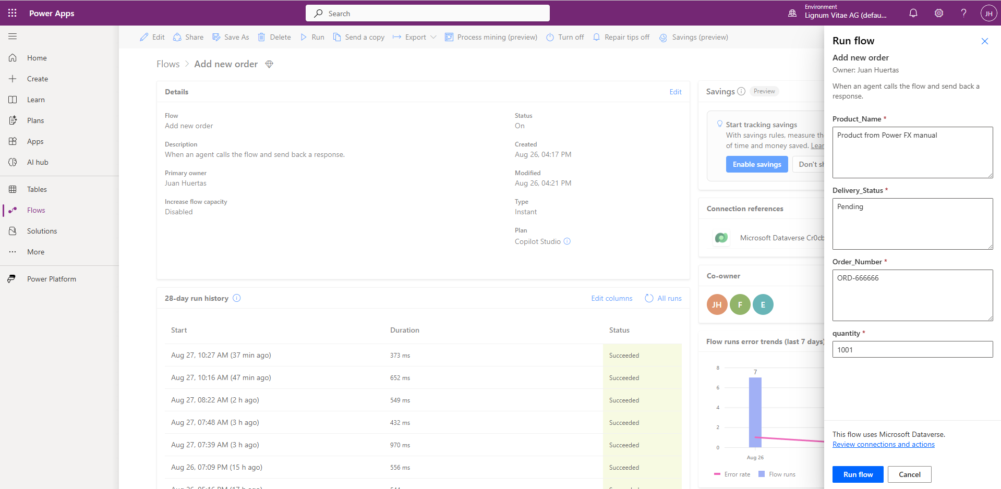

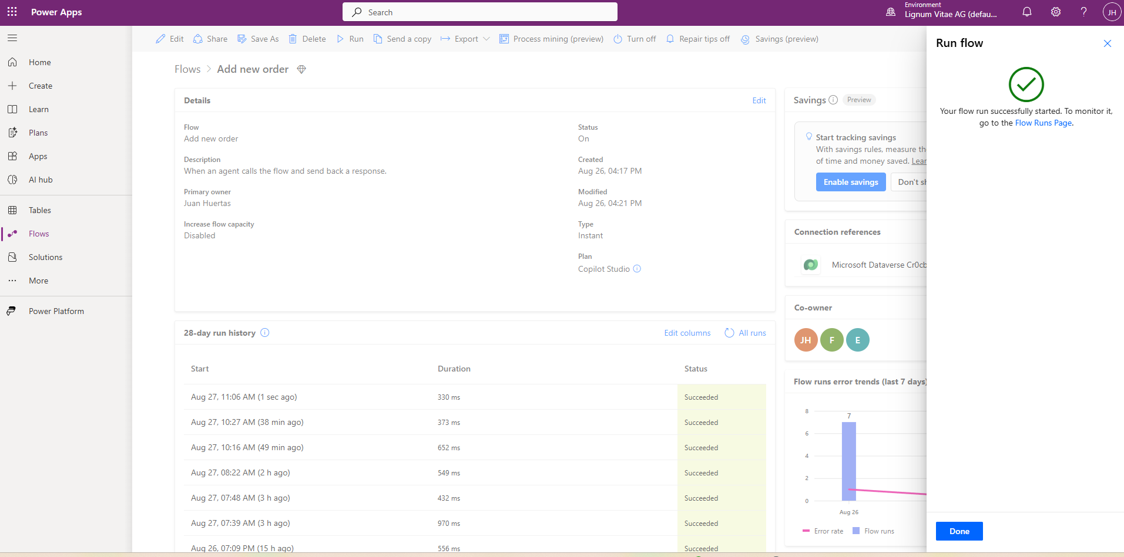

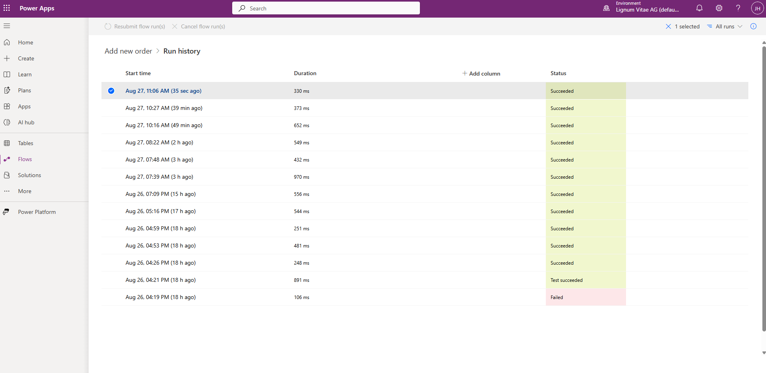

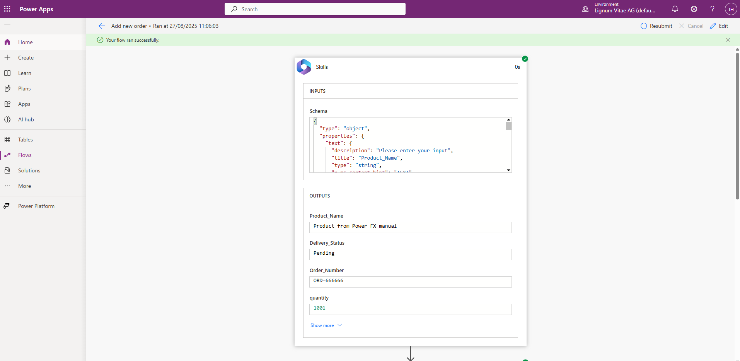

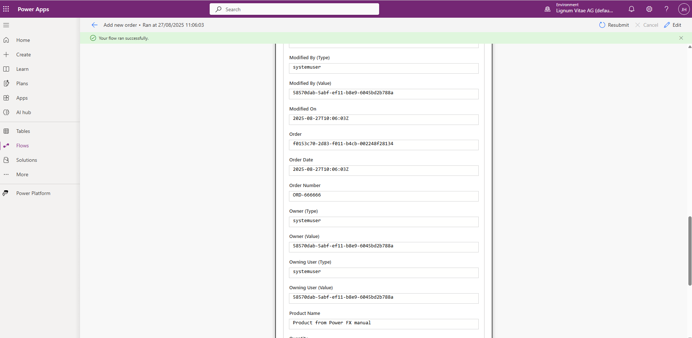

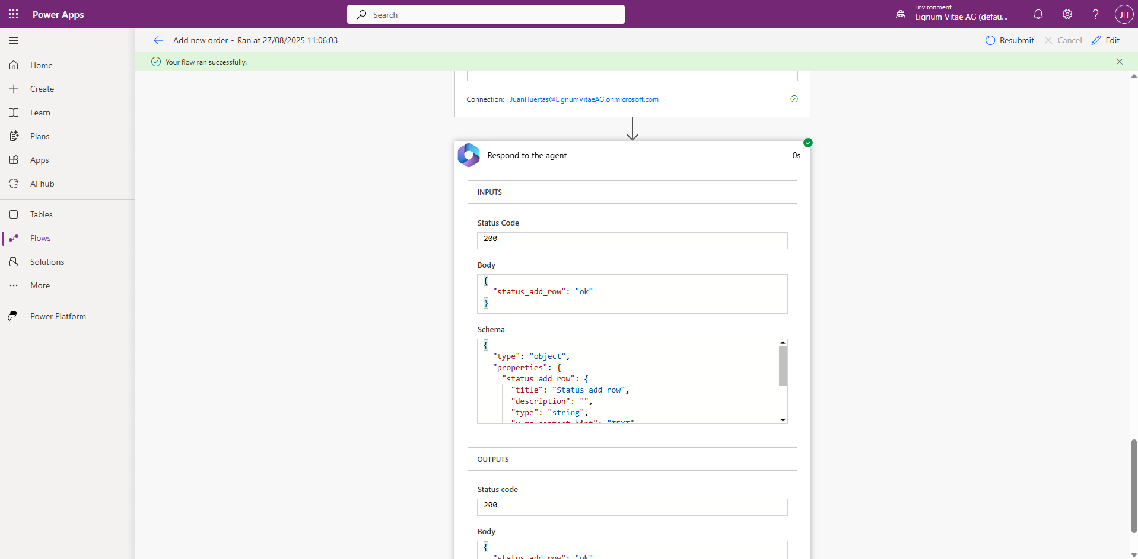

### Verify Creation In Table

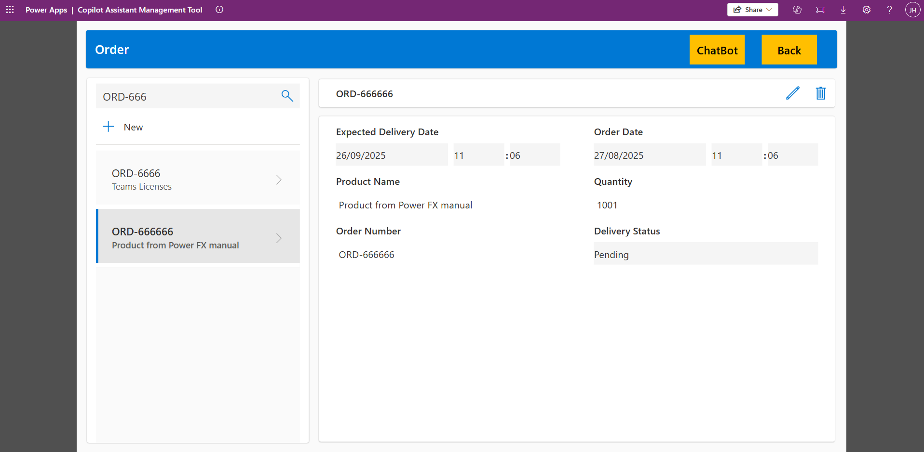

## Integrate Copilot functionality into the app

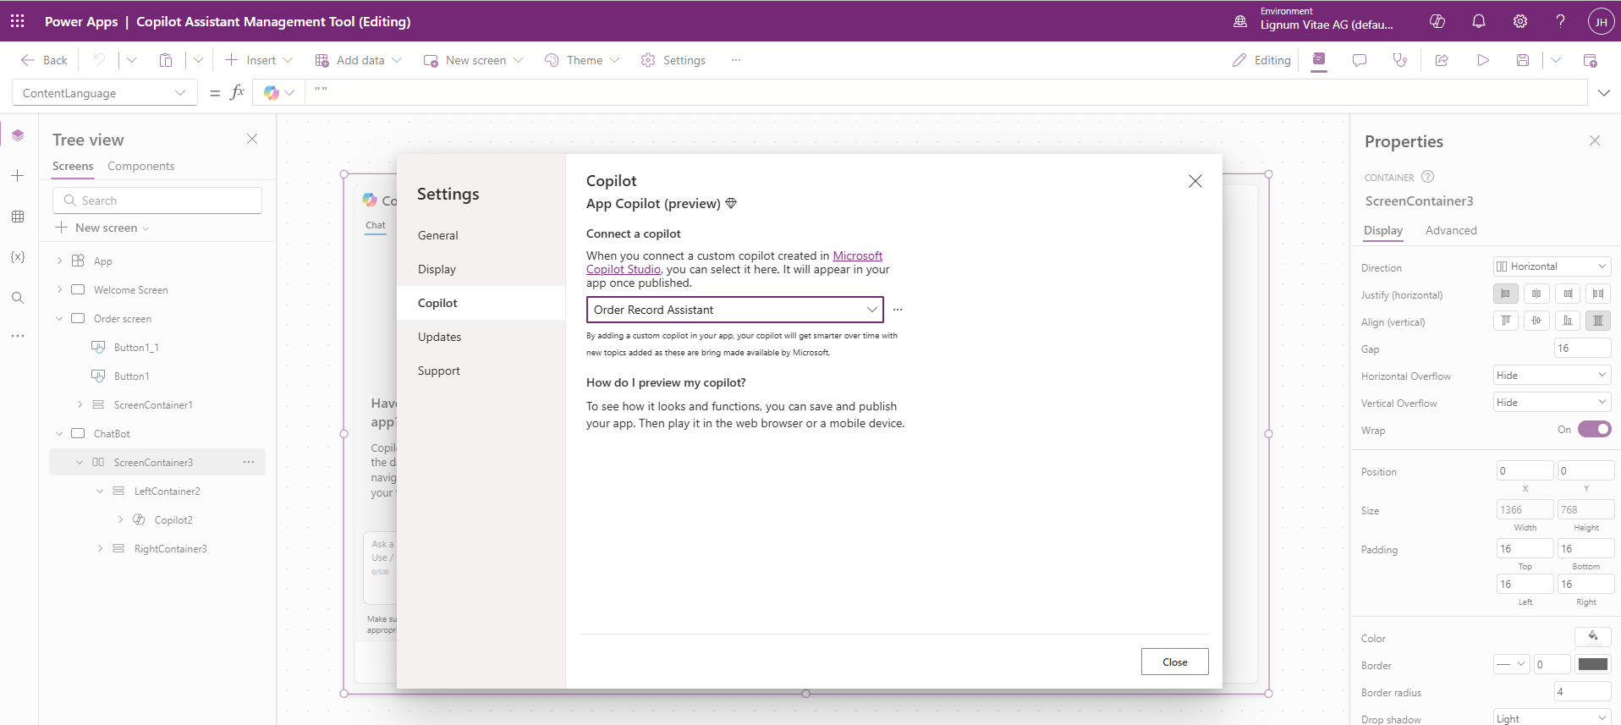

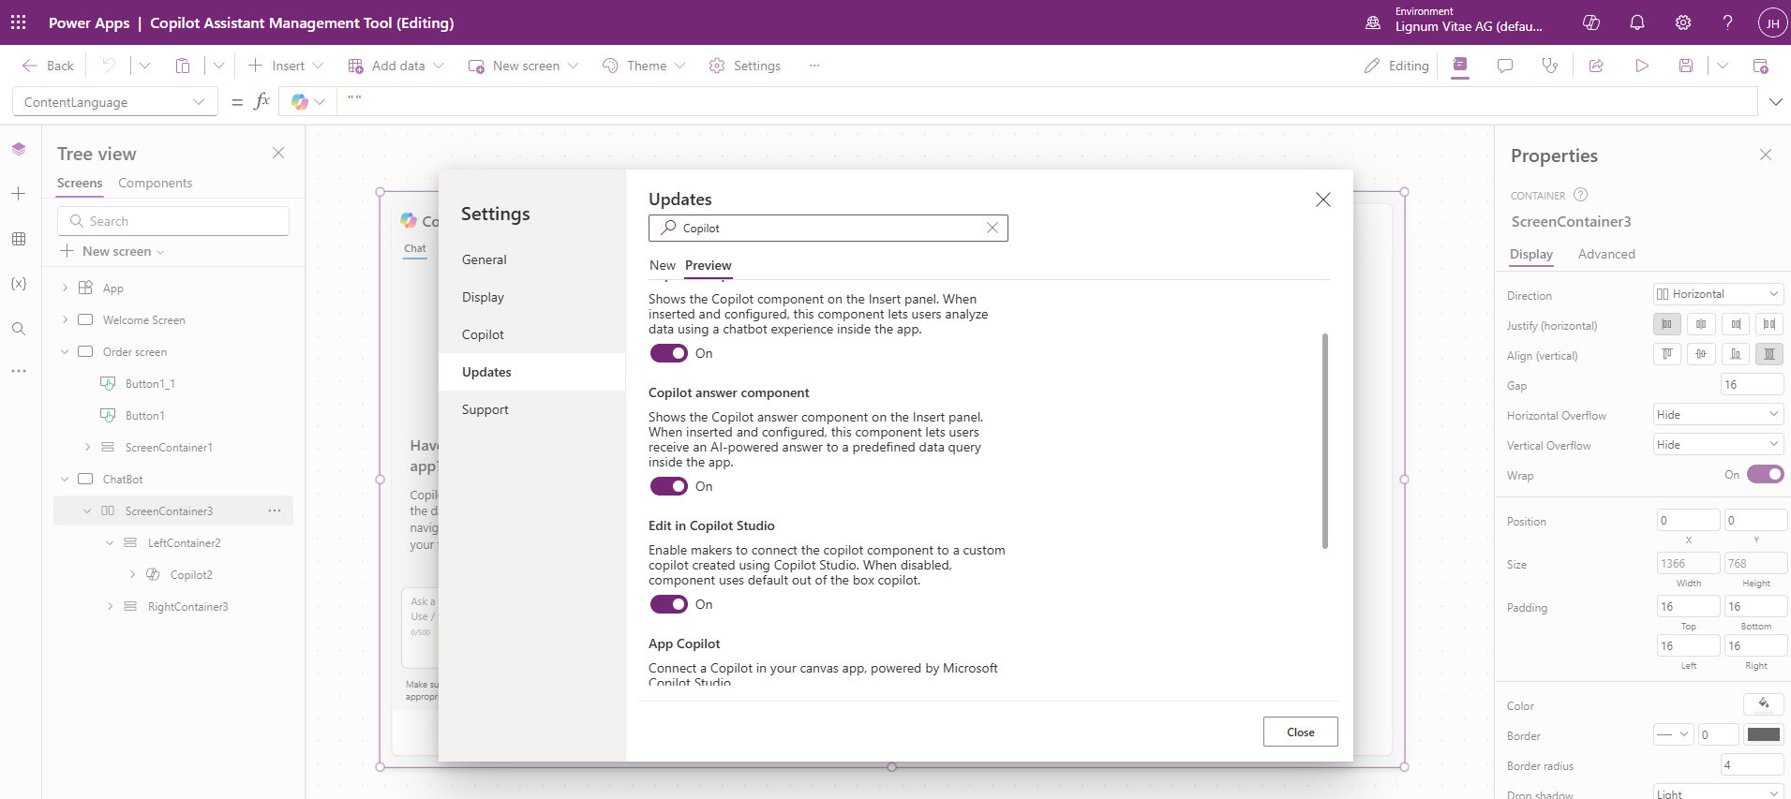

## APP Demo

### Welcome Screen

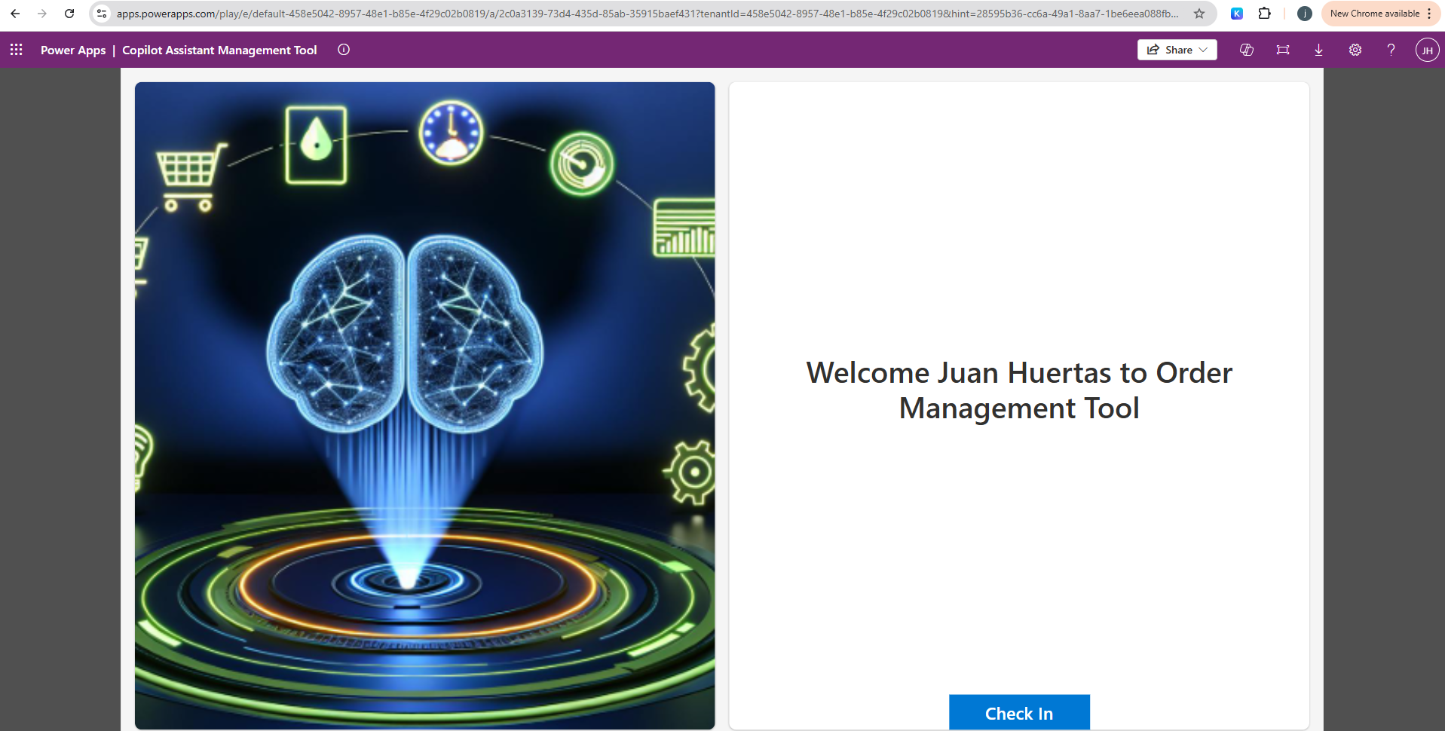

### Demonstrate navigation logic using Power FX (Click in Check In)

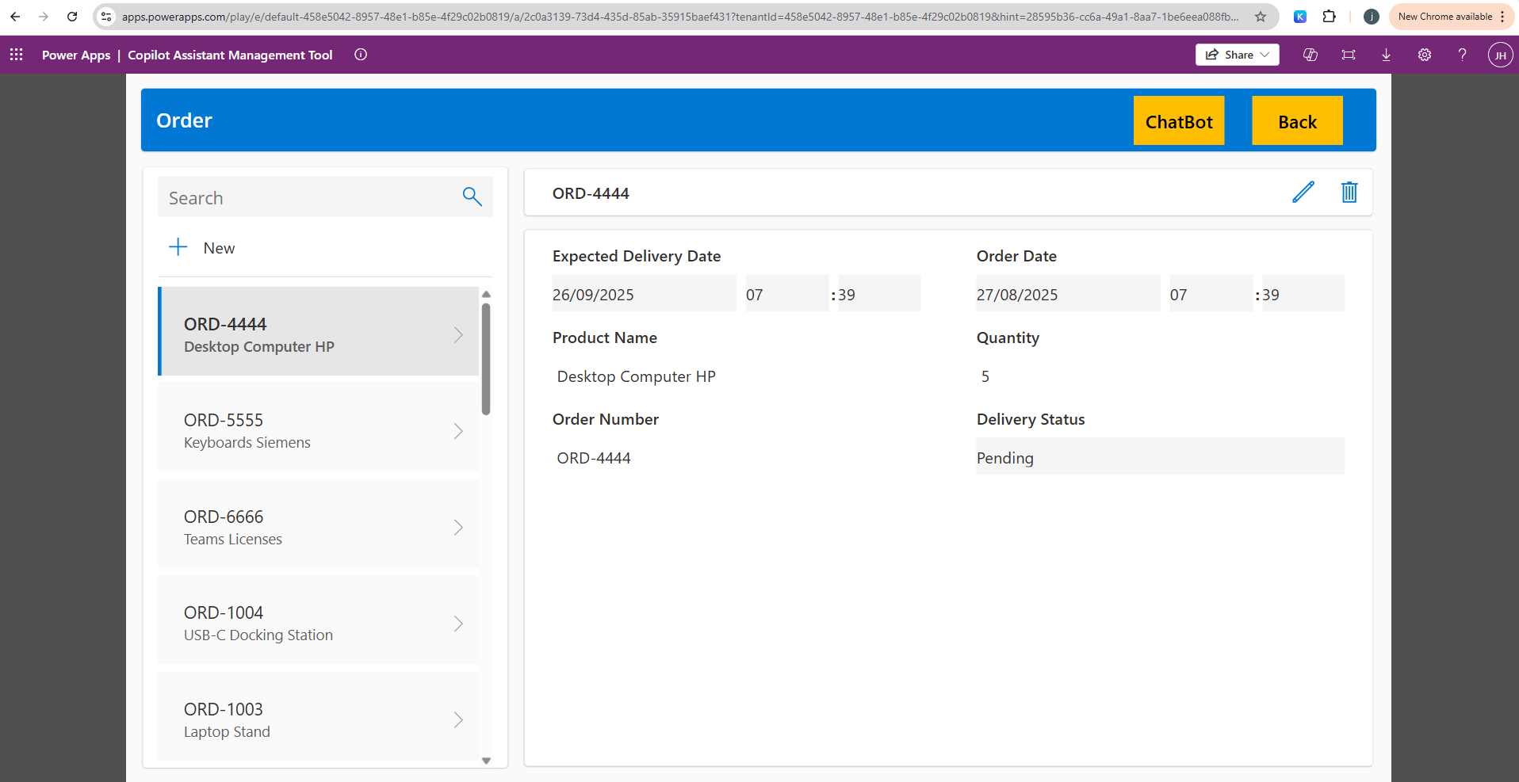

### Search Order

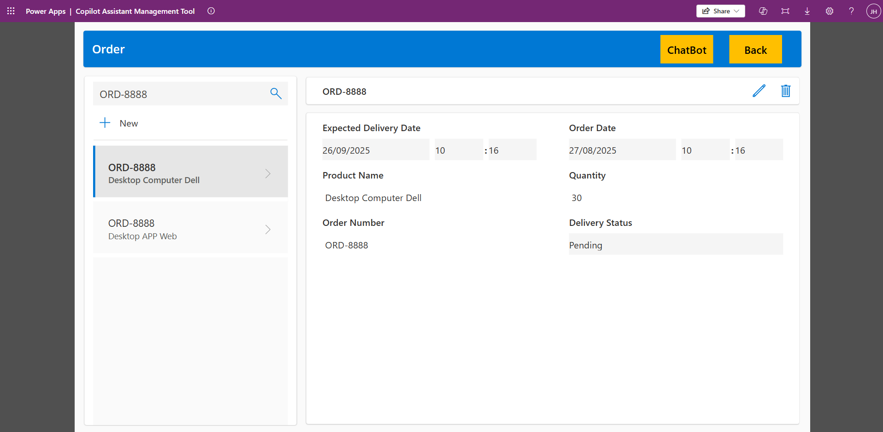

### Create New Order in Application

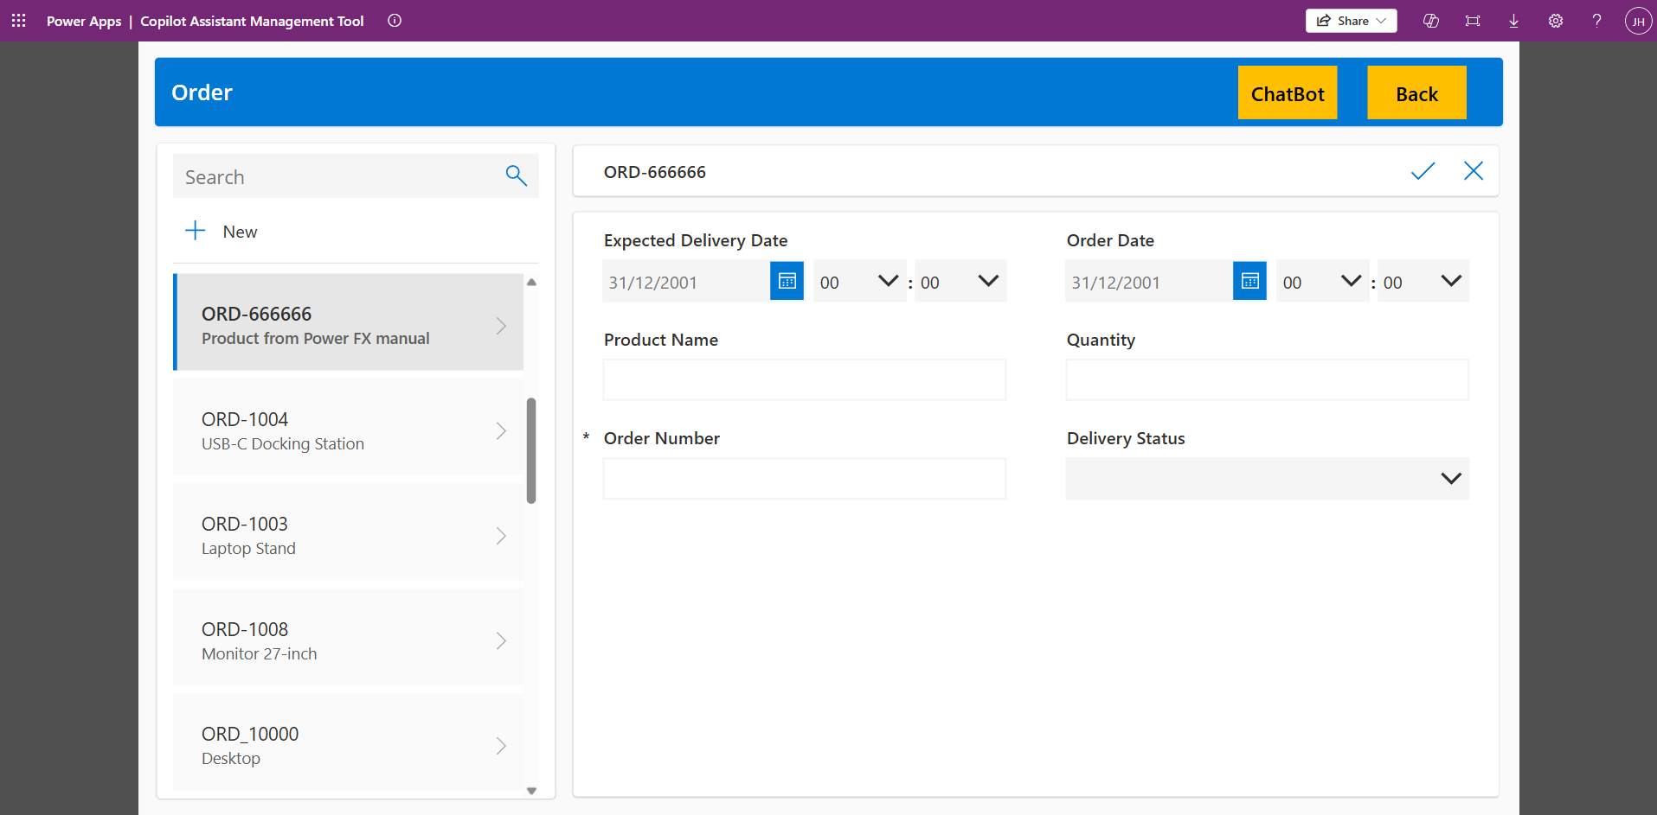

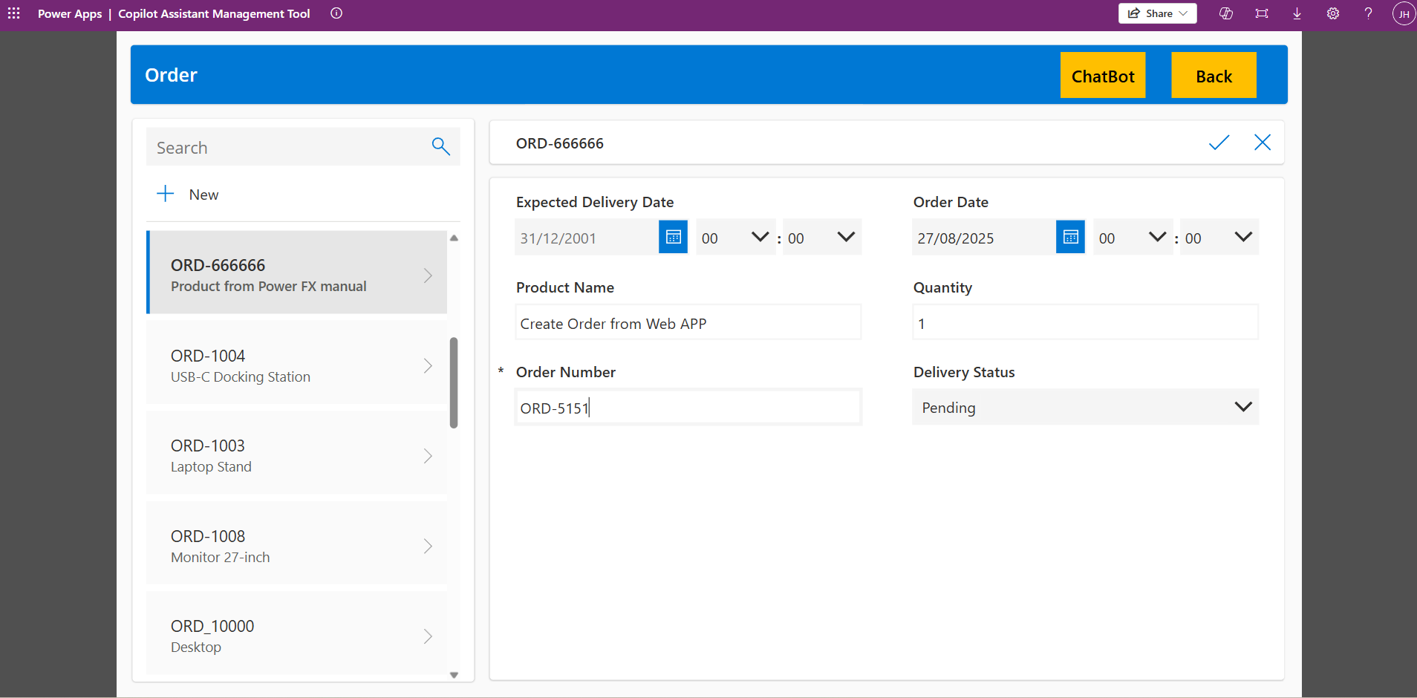

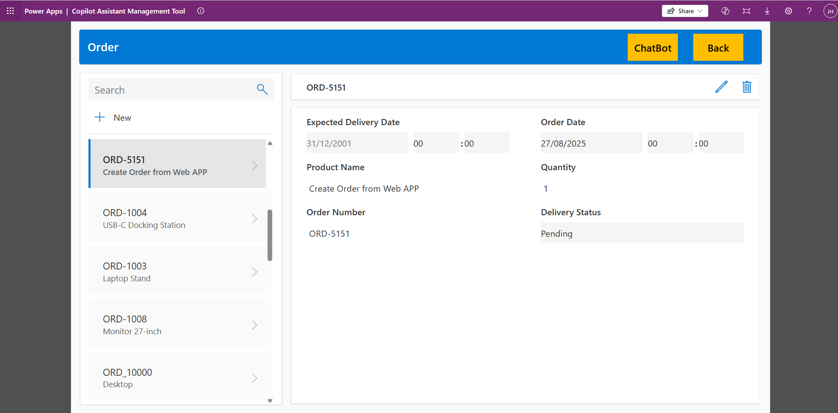

### Demonstrate user interaction with the Copilot Agent

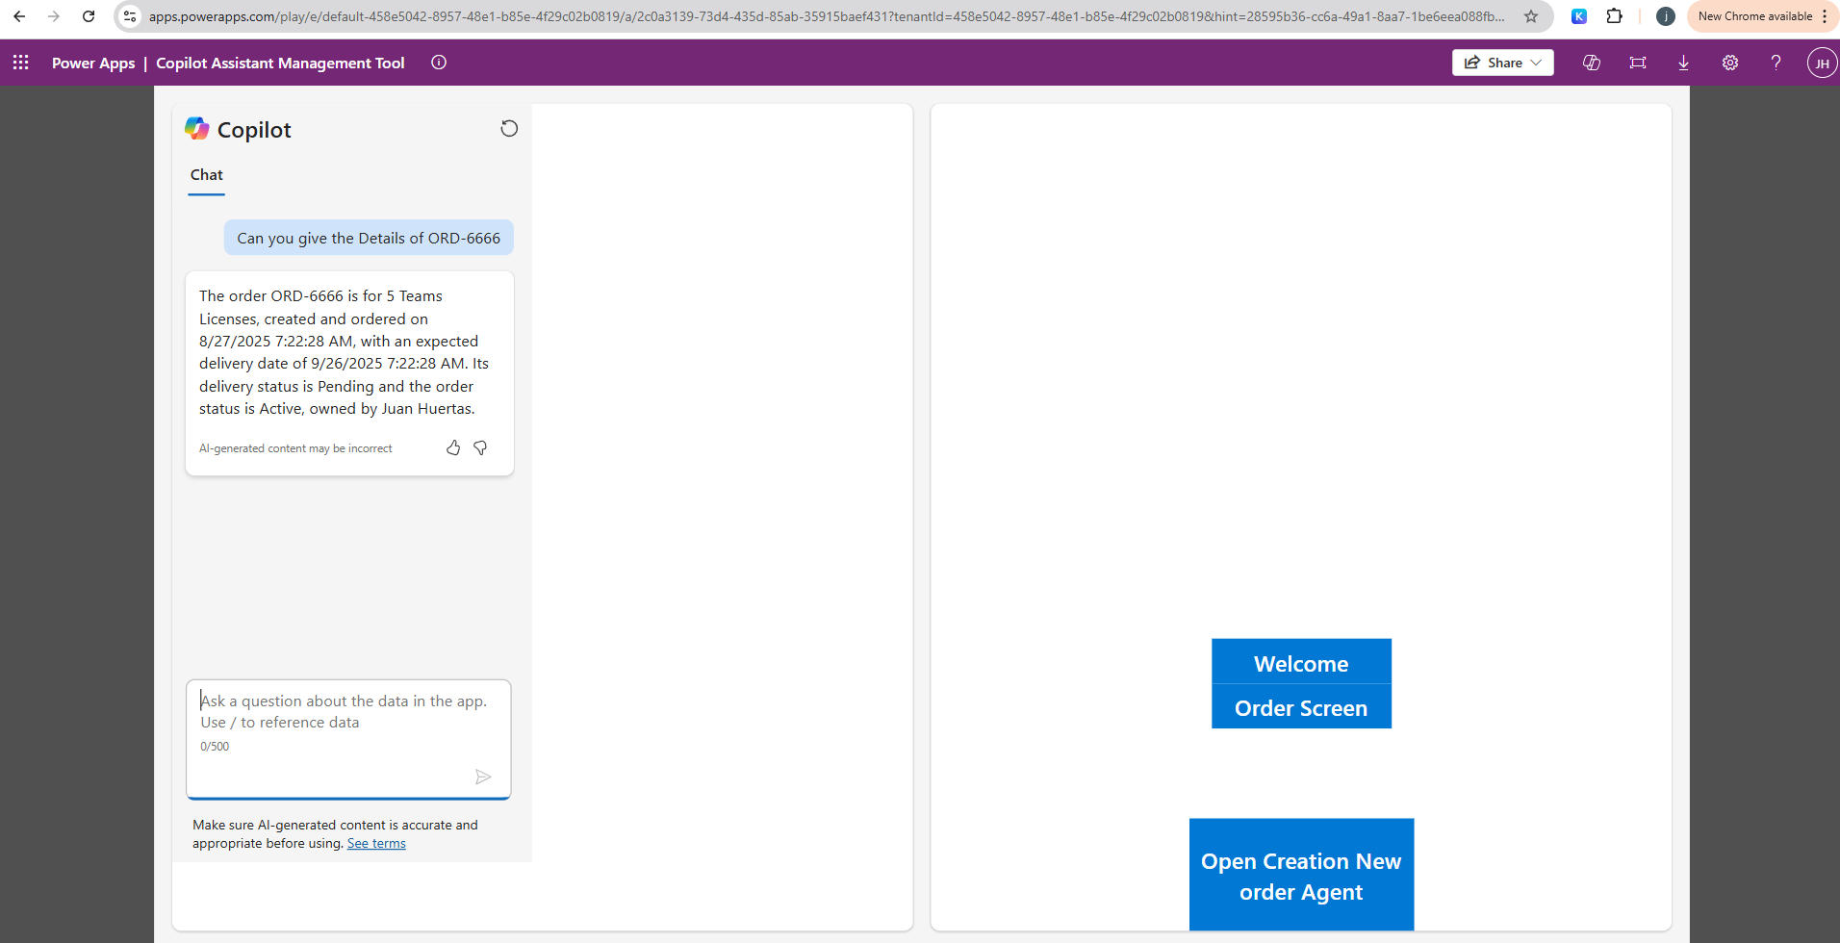

### Open Creation New Agent Button

#### Demonstrate user interaction with the Copilot Agent

#### Showcase the ability to create records via the Copilot Agent

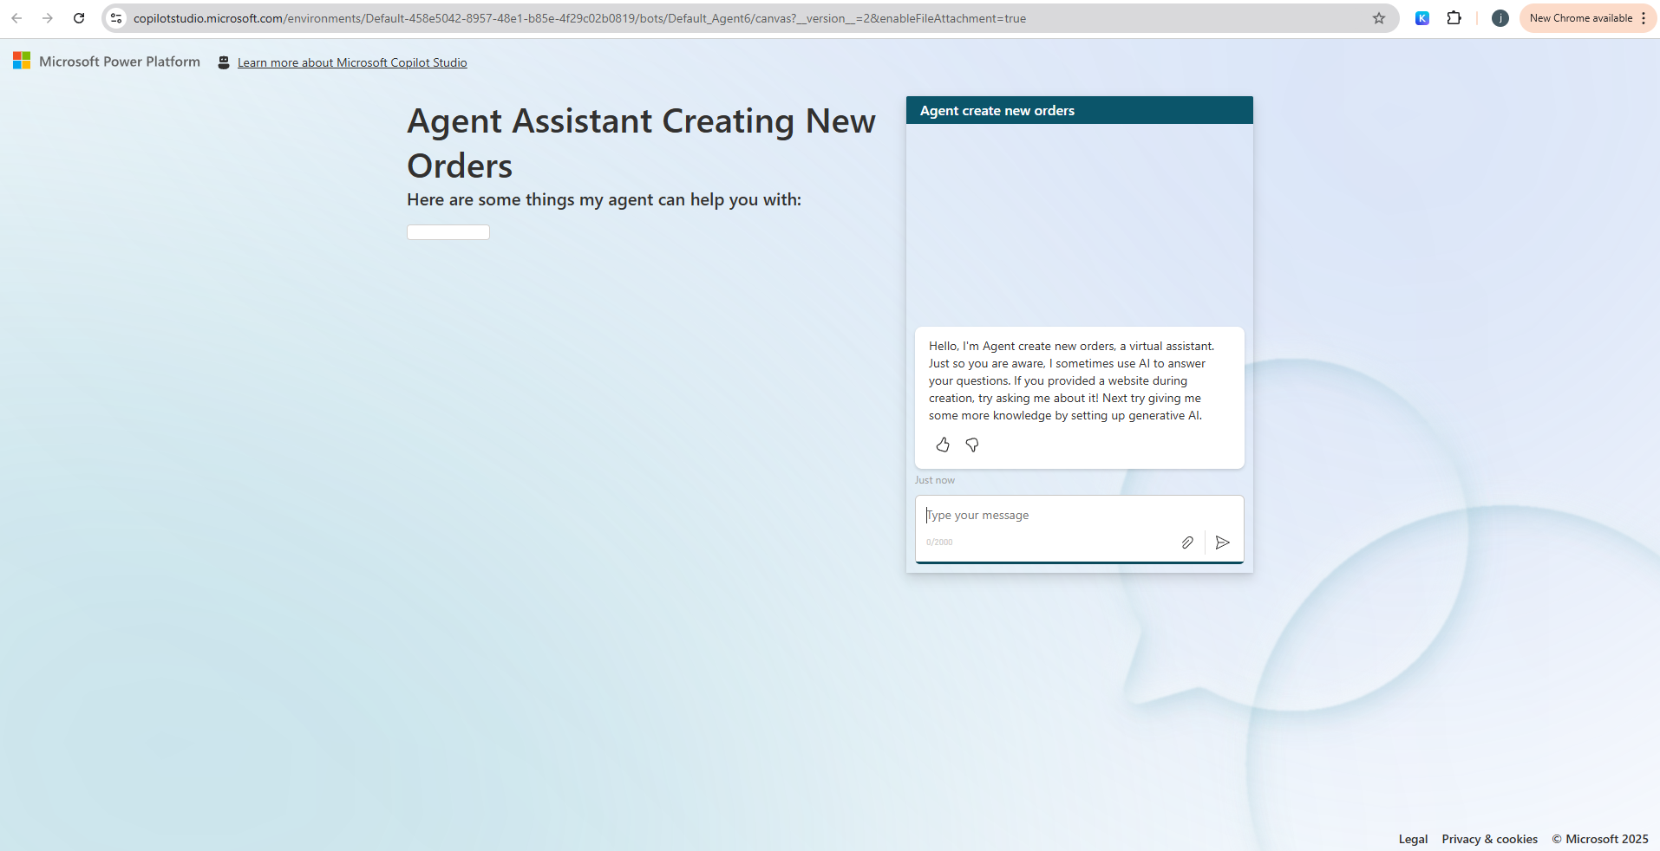

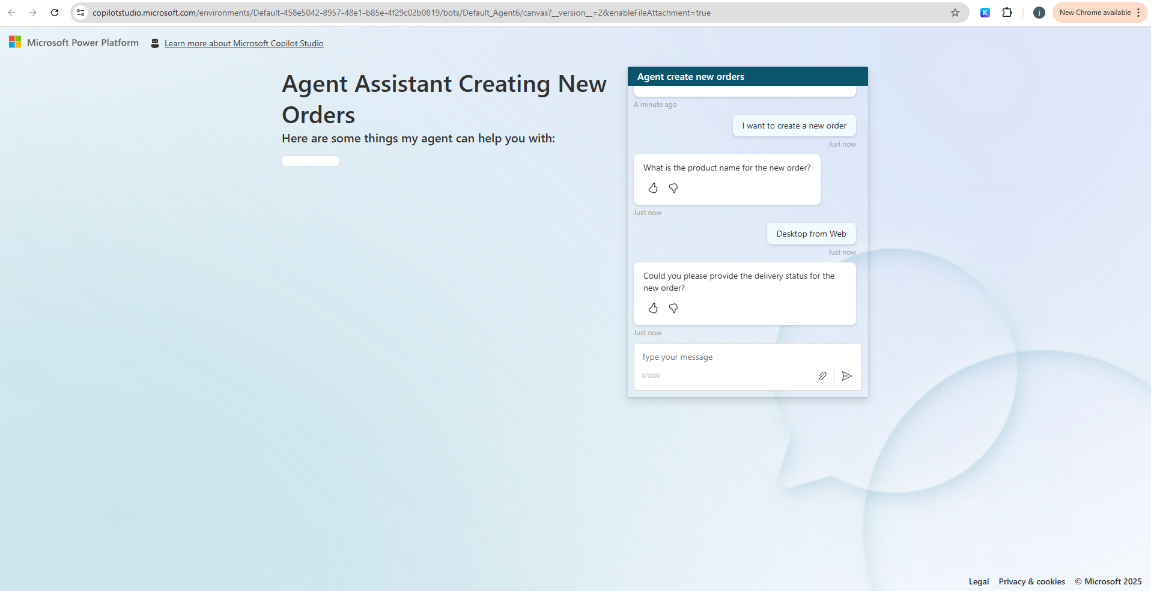

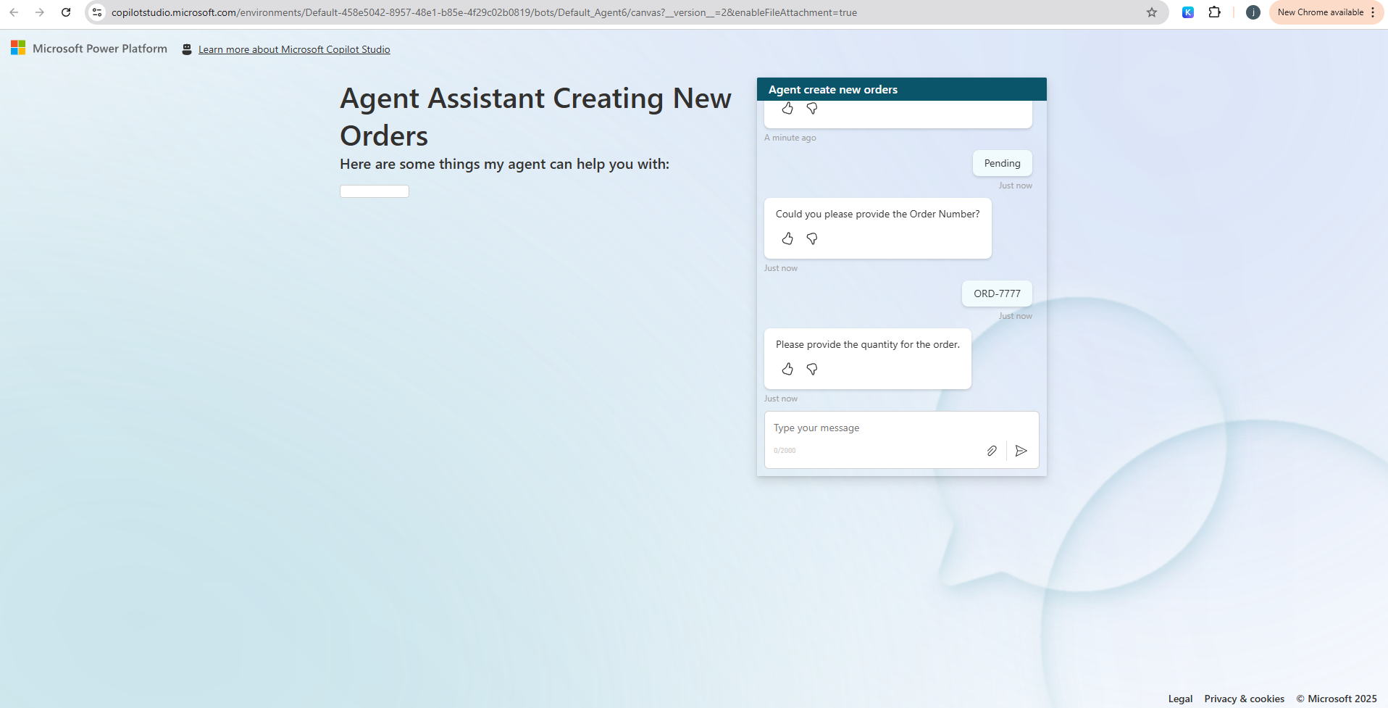

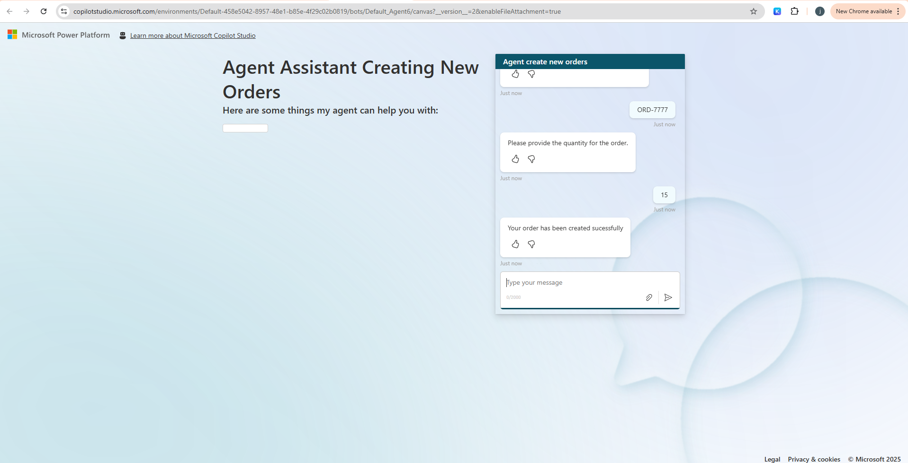

#### Validate the Dataverse Table

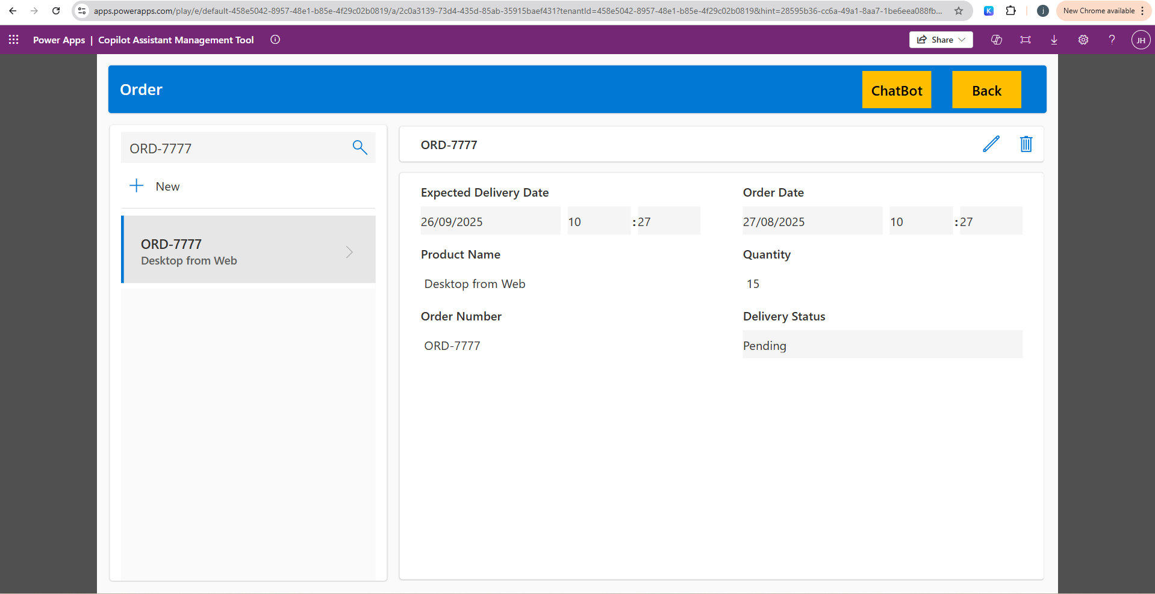

## Publishing Agent to Copilot and Teams Channel

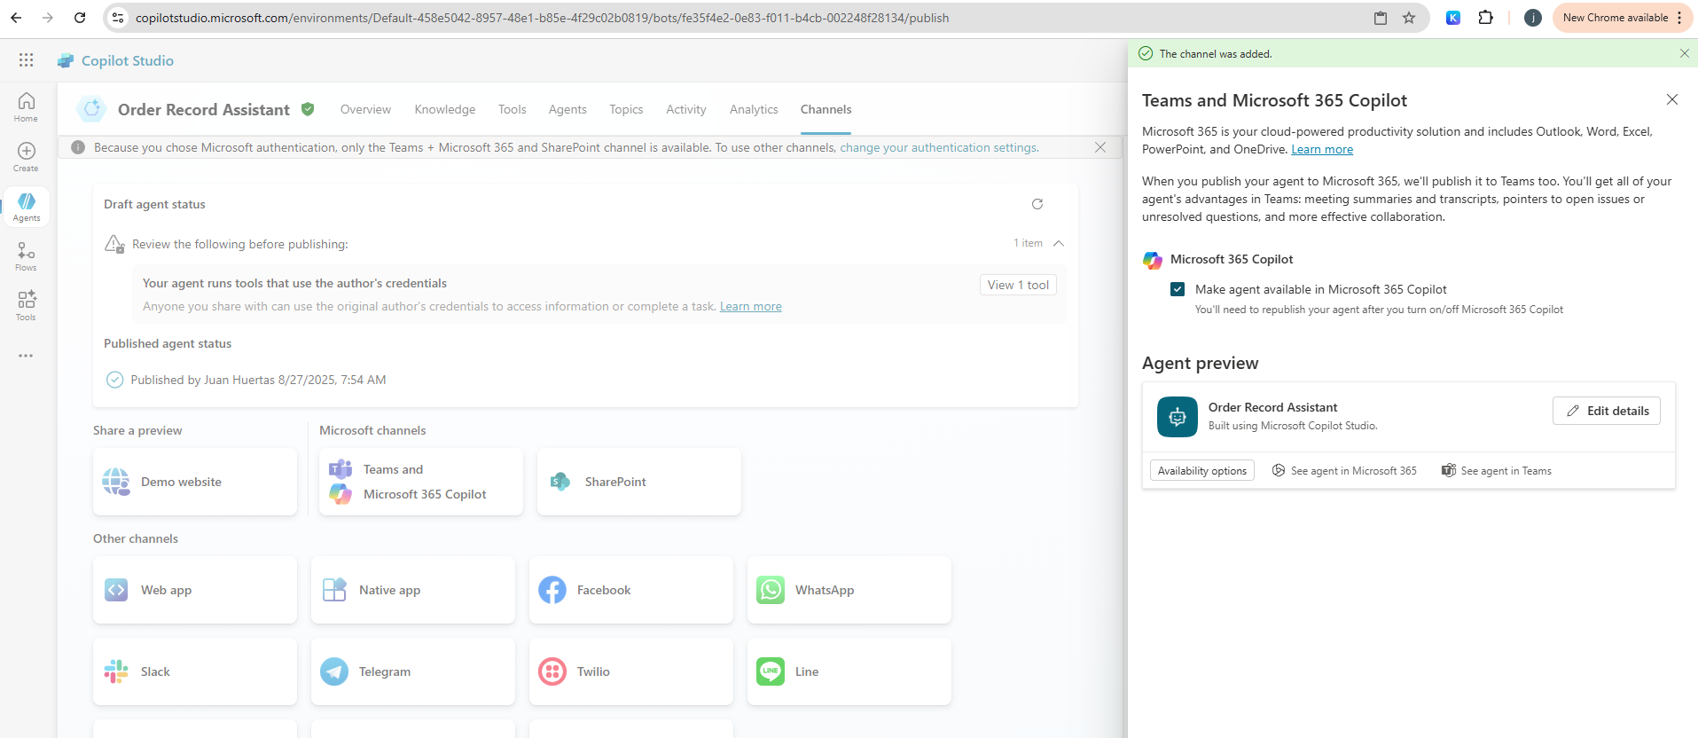

### Teams Agent (Demonstrate user interaction with the Copilot Agent)

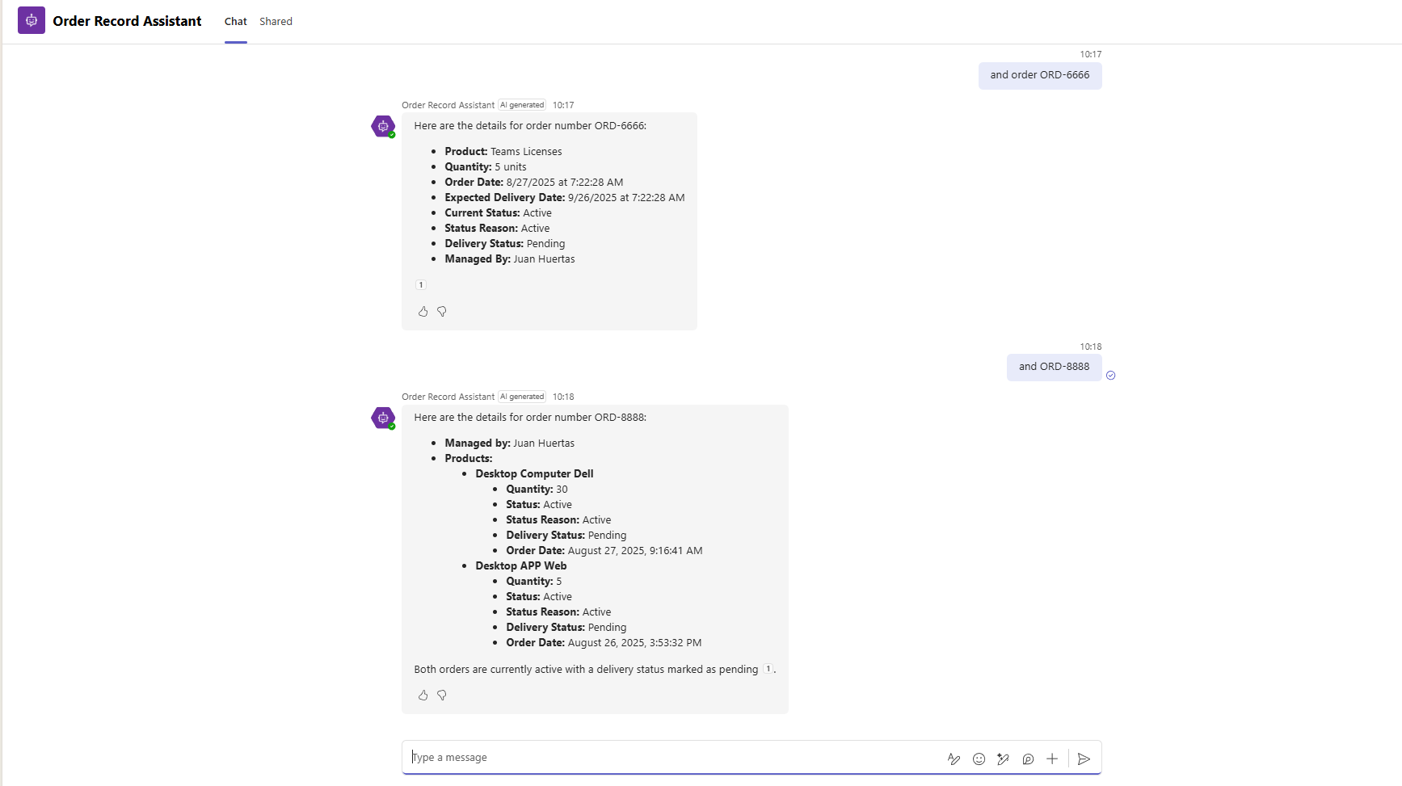

### Teams Copilot (Demonstrate user interaction with the Copilot Agent)

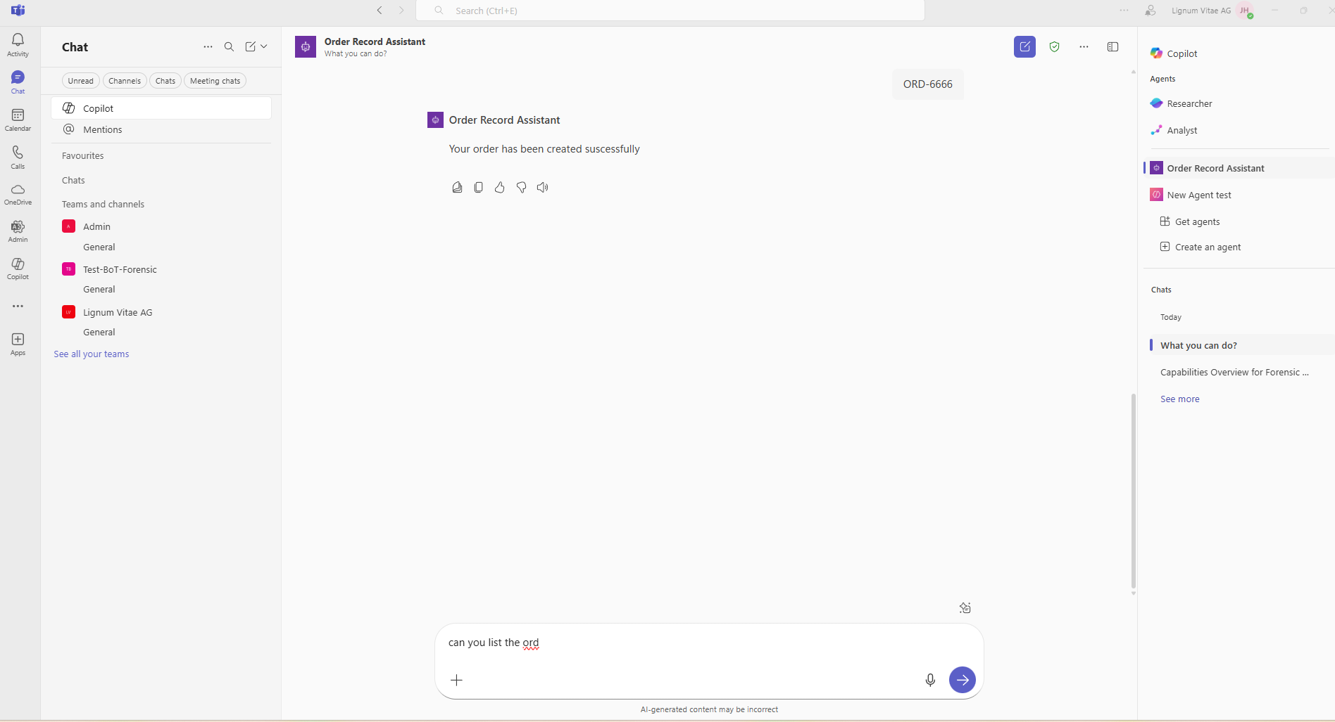

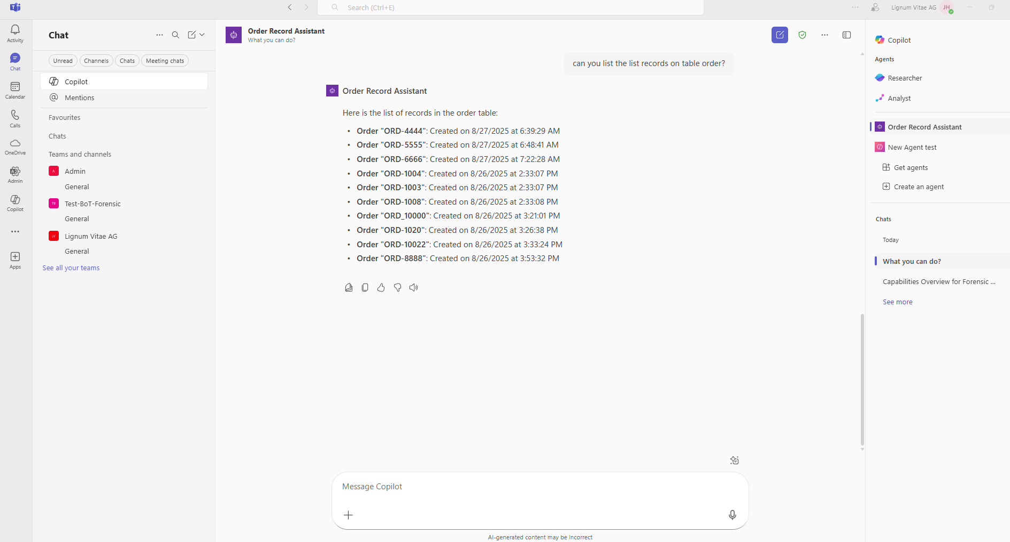

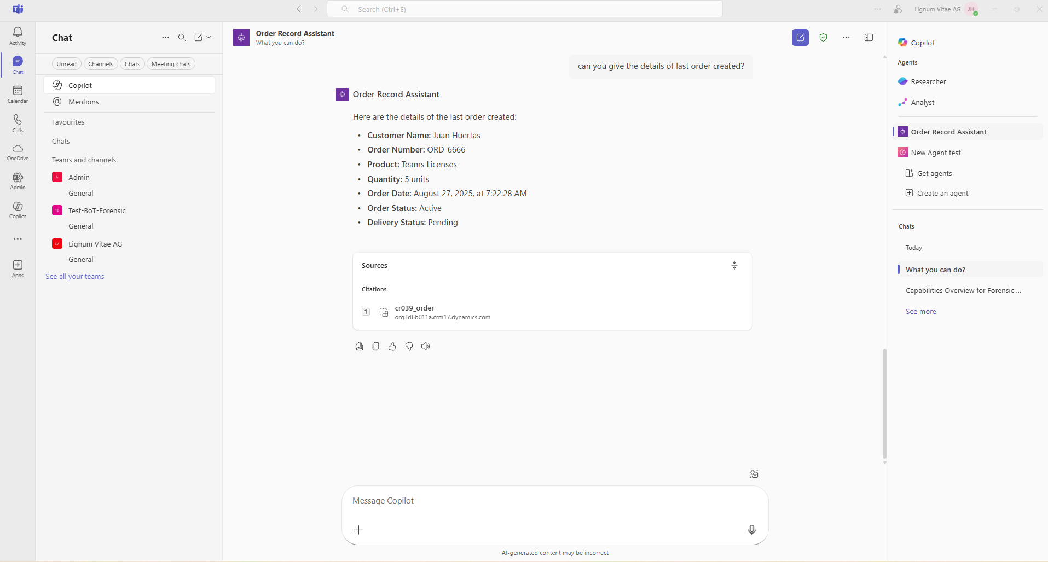

## Solution Copilot Assisted Management Tool

### Validate the structure of the Power Platform solution

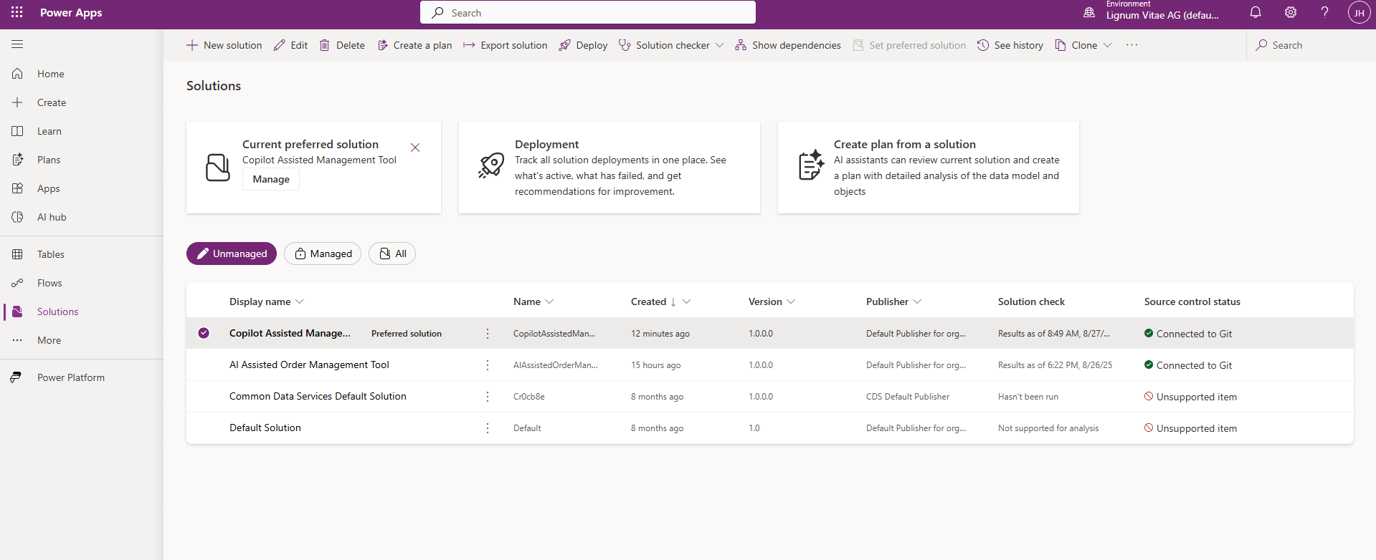

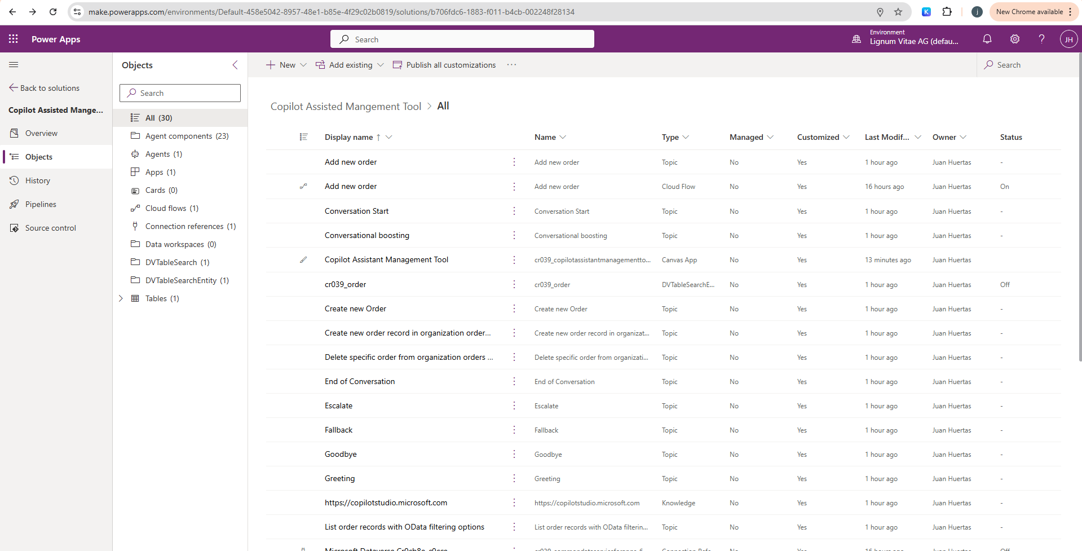

## Azure DevOps

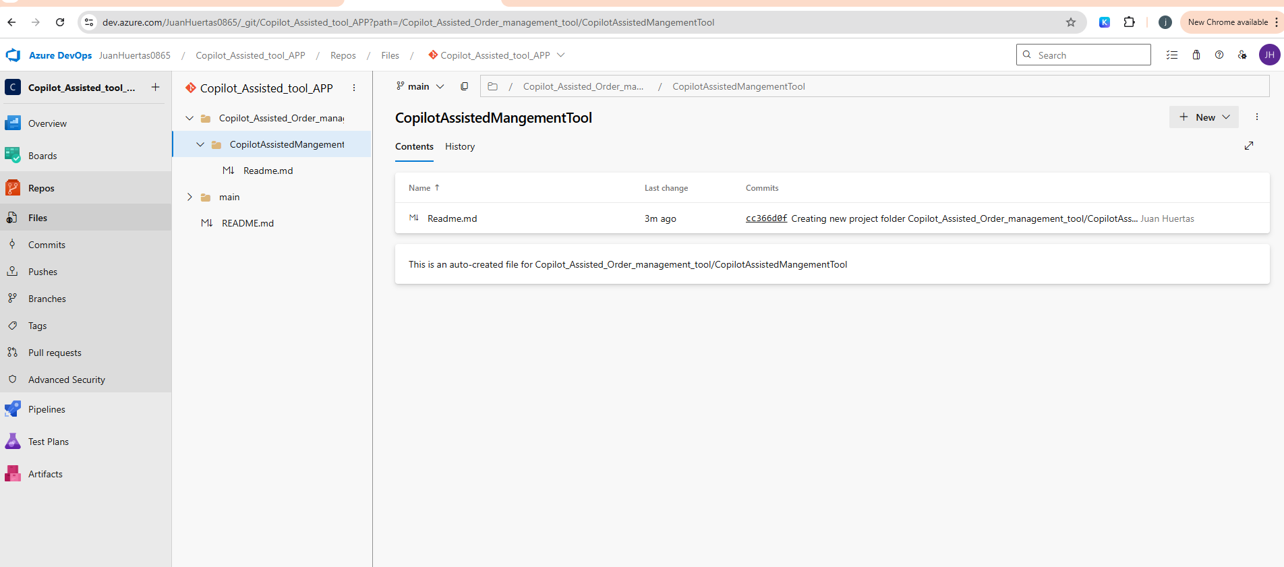

## VsCode

